2.7 The character of Alexander
It is difficult to make a final assessment of the character of Alexander. Although we have a considerable amount of material about the Macedonian king, we have little contemporary evidence. It is probable that the herm of Alexander originally found at Hadrian’s villa at Tivoli and now in the Louvre Museum can give us an idea of what he looked like. It is based on an original by the Greek sculptor Lysippus who ‘was the only sculptor Alexander judged worthy of portraying himself’ (Arrian 1.16). The accounts of his campaigns also enable us to understand his energy, particularly in warfare: his resilience, determination and courage are well documented. His judgment is more questionable: he was certainly decisive and intuitive in battle, but many historians have criticised the risks he took not only with the lives of his men but with his own. This was particularly important because he did not make provision for his own death: there was no clear succession and he had not followed Parmenio’s advice before the campaign began to father a successor. Events after his death showed how significant a problem this would prove to be.

We can certainly form a judgment of the impact he had on his men. The aftermath of the mutiny at Opis shows the very strong feelings between the army and their king (Arrian 7.11). His relationship with his companions was more complex. He was very close to Hephaestion, and to many of the others; the Macedonian tradition of free speech in the presence of the king made relations with some companions more difficult, as shown by the events leading to the death of Cleitus (Arrian 4.8).

Picture source: Herm of Alexander from Hadrian’s villa at Tivoli
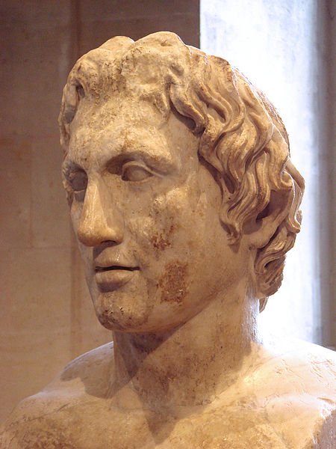

Alexander’s character
Modern historians have emphasised certain aspects of his behaviour, arguing that he was some or all of the following:
- an alcoholic
- a megalomaniac
- paranoid
- convinced of his own divinity.

Task 2F
Select passages from the sources you have studied to support the case for each of these descriptions.

Many of the ancient writers emphasise the negative or positive sides of the picture. Arrian (7.30), for example, is largely positive, and is critical of those who focused only on Alexander’s faults: he thinks that someone who draws attention to these should remember that he ‘is himself a meaner person who has pursued trivial goals and not even achieved these.’

On the other hand, Cleitarchus was responsible for some of the negative stories to be found in the surviving sources about Alexander. He had access to eye witness accounts for some at least of what he wrote, and he preserves important details; however his interpretation of Alexander’s actions is equally open to question.

Task 2G
Present a critical discussion of the following assessment of Alexander, selecting three or four incidents from Alexander’s life to support your case.

If Alexander made mistakes through haste or anger, or if he was led on to act in a barbarian and rather arrogant manner, for my part, I do not consider these serious faults, if one considers reasonably Alexander’s youth and his continual success and the nature of such men as associate, and will always associate, with kings to please them, not for the best of motives, but for evil. I know that the remorse he showed when he had done wrong because of the nobility of his nature was unparalleled amongst the kings of old.
Arrian 7.29

It may be helpful to make a list of significant events from Alexander’s life and contrast the different interpretations that can be made of it. There may be a variety of possible interpretations possible.

Example:

Event | Positive Interpretation | Negative interpretation
Alexander’s adoption of Persian dress | To demonstrate to the conquered peoples that he was the rightful heir of Darius III | Shows Alexander’s desire to be treated as a Persian king rather than a Macedonian

