Put the title The Monastic Life in your exercise book.

§1 - A Monk’s Life
Task One
Working in a small group or as a whole class, study the Introduction and Source 1 and:
1. Share, look up, or ask the meaning of the following words: poverty, obedience, chastity.
2. Study the pictures in turn. For each, read the caption, and decide whether this illustrates work, study or prayer. Which pictures do not fall into any of these categories?
3. Find in Source 1 examples of the following elements of a monk’s dress:
- Tonsure (to represent the crown of thorns).
- Habit (made of rough, scratchy cloth to remind them of Christ’s suffering).
- Belt (or ‘girdle’, to remind the monks that they were still bound to this world).
- Sandals (to remind the monks that they had to be humble like Christ).
4. Monks went to eight services a day. Working on your own, draw a 24-hour timetable in your exercise book, marking in the correct order the activities on the worksheet ‘A Monk’s Day’.
As you prefer, add drawings from the worksheet or from the webpage.

§2 - The Monastery
Task Two
Working in a small group or as a whole class, study Source 2 and:
1. Share, look up, or ask the meaning of the following words: Church, Cloister, Warming House, Chapter House, Abbot’s House, Lavatory, Reredorter, Infirmary, Hospital, Dormitory, Refectory and Cellarium. Write the names onto 12 large flashcards and stick them up round the classroom.
2. Look at the reconstruction of Fountains Abbey on the webpage or the worksheet: ‘Fountain’s Abbey in the Middle ages’. ‘Read round’ the labels, explaining and discussing the buildings:
- Church: why is it so much bigger than all the other buildings?
- Cloister: the cloister was the covered way around the courtyard. The monks read and copied books here, even in winter!
- Warming House: what did the monks do when copying in winter?
- Chapter House: what happened here?
- Abbot’s house: who was the abbot?
- Lavatory: in the Middle Ages, this was a place where you washed (from the Latin lavare: to wash). Later it became, firstly a euphemism, then a common name for the toilet. Medieval latrines were so smelly that they kept away clothes moths, so people kept clothes there; hence the latrine became (in French) the garde robe, and thence (in English) the ‘wardrobe’ – so medieval monks washed in the lavatory, and went to the toilet in the wardrobe!
- Reredorter: the correct name for the monastery latrine.
- Infirmary: the place where the sick, and the aged and infirm were cared for.
- Hospital: the place where hospitality was given (i.e., the guest house). NB: the monastery hospital had nothing to do with the sick.
- Dormitory: for sleeping. It was connected to the church by the night-stair.
- Refectory: dining room.
- Cellarium: where the cellarer stored food and wine. NB: it was not underground.
2. Practice in your group, learning the different parts of a monastery, and what happened there. Using this knowledge and the flashcards you stuck up round the room, pretend you are a tour guide and give the class a guided tour of the ‘monastery’, taking it in turns to talk about the different places.
A Monk’s Day
(Not in the correct order)
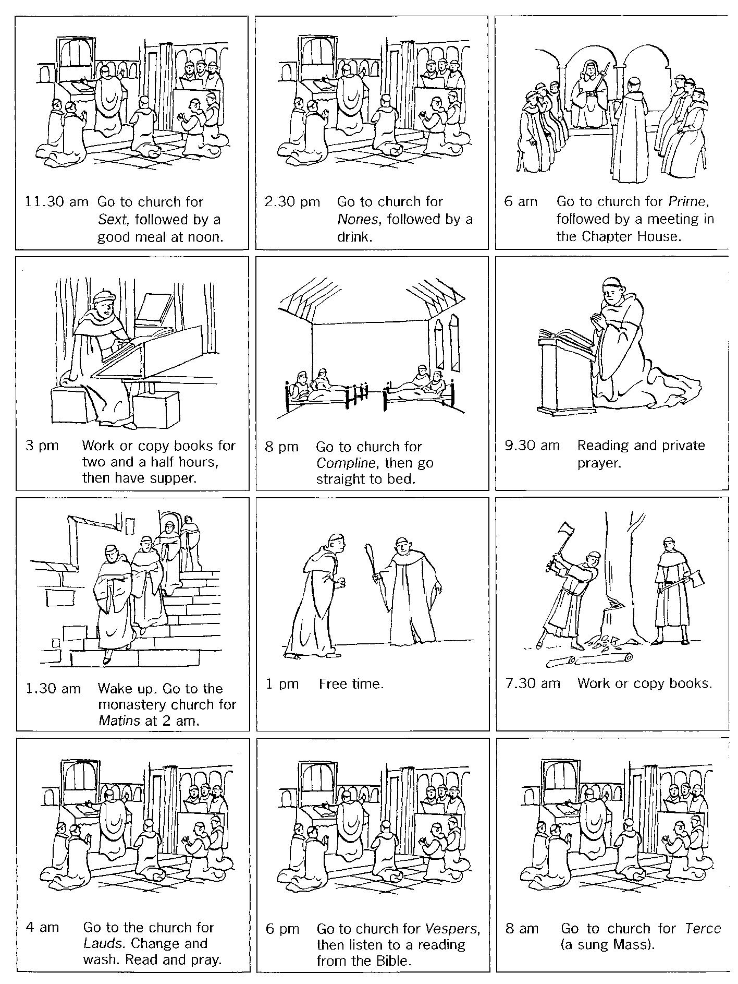
Fountains Abbey in the Middle Ages
(A modern reconstruction of what Fountain's Abbey would have been like in the Middle Ages.)
