Put the title Guilds in your exercise book.

Study all the information on the webpage.

Task One
1. Working in a small group or as a whole class, discuss the following:
- The process by which a person became a skilled craftsman in medieval England.
- Surnames began to appear in the Middle Ages, and many people were named after their trade – e.g. Carpenter, Miller, Barber and Cook. What surnames came from the trades shown in pictures 1-4?
- How many health and safety rules can you see being broken in Source 4?
- Go through rules a-j in Source5; try for each to suggest WHY the Guild insisted on this. (Suggested answers below.)

Task Two
1. Do the worksheet: ‘The Guilds’.

Answers:
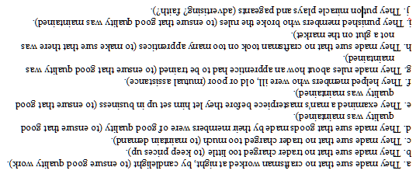
The Guilds

A Understanding the passage (Circle the right answer — sometimes more than one is right.)
1 In a town street in the Middle Ages you would find:
bakers and goldsmiths clubs called guilds people of the same trade

2 An apprentice:
was given beatings learned a trade was a skilled employee

3 A master craftsman:
lived in the same street made a masterpiece set up a business

4 Towns were places where the following people set up business:
farmers and traders traders and craftsmen farmers, traders and craftsmen

5 Surnames began to be used in the Middle Ages because:
towns grew people were named after their trade people formed guilds

B Understanding the words (Write a sentence to explain what each word means.)
6 Surplus: ..……………………….……………………………………………………………….
7 Trade: ……..…………………….……………………………………………………………….
8 Apprentice: .…………………….……………………………………………………………….
9 Skilled: …….…………………….……………………………………………………………….
10 Journeyman: ..………………….……………………………………………………………….
11 Submitted: ..…………………….……………………………………………………………….

C Understanding sequences (Put into the correct order.)
12 If anyone wanted to become a member of a guild, their life story went like this:
Wrong order: | Correct order:
• Journeyman | 1st: …………………………………………………………………….
• Apprentice | 2nd: …………………………………………………………………….
• Master craftsman | 3rd: …………………………………………………………………….
• Child | 4th: …………………………………………………………………….
• Learning the trade | 5th: …………………………………………………………………….
(Put an arrow showing the point in the list when the man submitted his masterpiece.)

