Put the title King Philip’s Problems in your exercise book.

Read the information on the webpage, then:

Task One
1. Working with a partner or on a small group, study the Introduction and Source 1.
Note that you will need an atlas to complete the following task:
- Mark onto the map of ‘Philip II’s Empire’ the modern names of all the places he ruled.
- Colour in the lands which formed his Empire.

Task Two:
1. Working with a partner or in a small group:
- Read and discuss the section King Philip II’s Problems.
- How was problem 9 linked to problem 12?
- Can you find any other problems which are connected in any way?
- Can you find any common themes – what lay behind all Philip’s problems?

2. Put a dot in the centre of the worksheet ‘The Problems of Philip II’ and draw a line to every problem in which England was involved in any way.
- Answer the question again – what lay behind all Philip’s problems?
- The English, at the end of the 16th century, were the terrorists of Europe! If you were Philip, how would you have dealt with them?

3. Put the ten problems with dates in chronological order (if necessary cut up a copy of the worksheet ‘The Problems of Philip II’ and arrange the ten cards on the desk.

4. Coming together as a whole class, discuss:
- ‘Looking at the list of events/dates, when do you think Philip eventually decided that he would have to go to war with England?’ Support your ideas with facts and reasoning.
- Whose fault was the war?
- Was war with England ‘inevitable’?
Philip II’s Empire
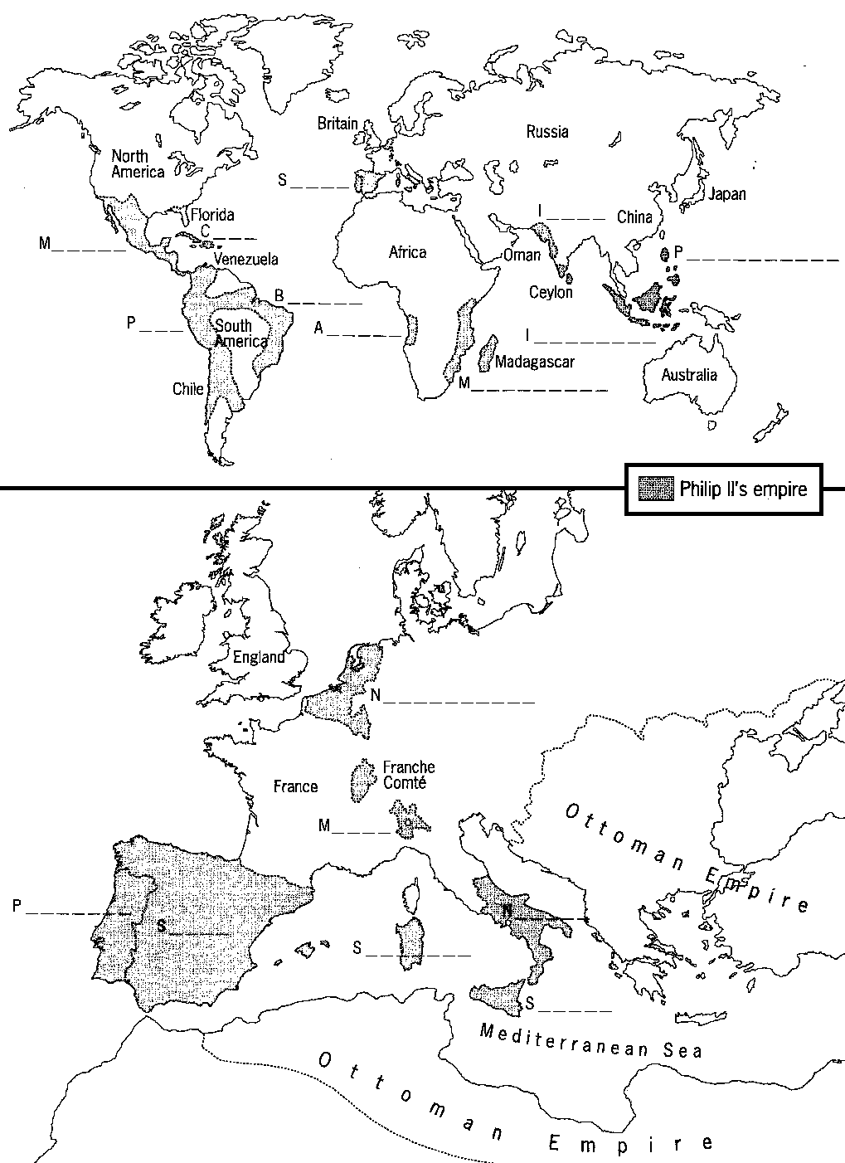
The Problems of Philip II

