Put the title The Armada in your exercise book.

Read the information on the webpage, then:

Task One
1. Working with a partner, use the worksheet ‘The Armada’ to list the events of the Armada in the correct order. Copy the sentences, in the correct order, into your notes, illustrating the events with appropriate illustrations.

Task Two:
1. Working in a small group of four to six students, play ‘The Armada Game’.
- You will need a die and a marker.
- The game is conjectural history, of course – things didn’t happen in real life exactly how they happened to you in your game, but it gives you an idea of the kind of things that happened at various points in the story of the Armada.

3. Use the Armada Game rules to make a list of all the different kinds of disasters that happened to the ships in the Armada.

4. Working again with a partner:
- One of you writes ‘The Story of the Armada’ as though you were a Spanish sailor. Use the words ‘we’ and ‘our’ for the Spanish fleet, and ‘they’ and ‘their’ for the English. Write your account as an historical novel which does not just list the events, but shares how you are feeling at the various points of the story.
- The other of you writes ‘The Story of the Armada’ as though you were an English sailor. Use the words ‘we’ and ‘our’ for the English fleet, and ‘they’ and ‘their’ for the Spanish. Write your account as an historical novel which does not just list the events, but shares how you are feeling at the various points of the story.
- Compare your stories. How do they differ?

5. Coming together as a whole class, share what you have learned from this lesson.
Did the English ‘beat’ the Armada?
The Armada

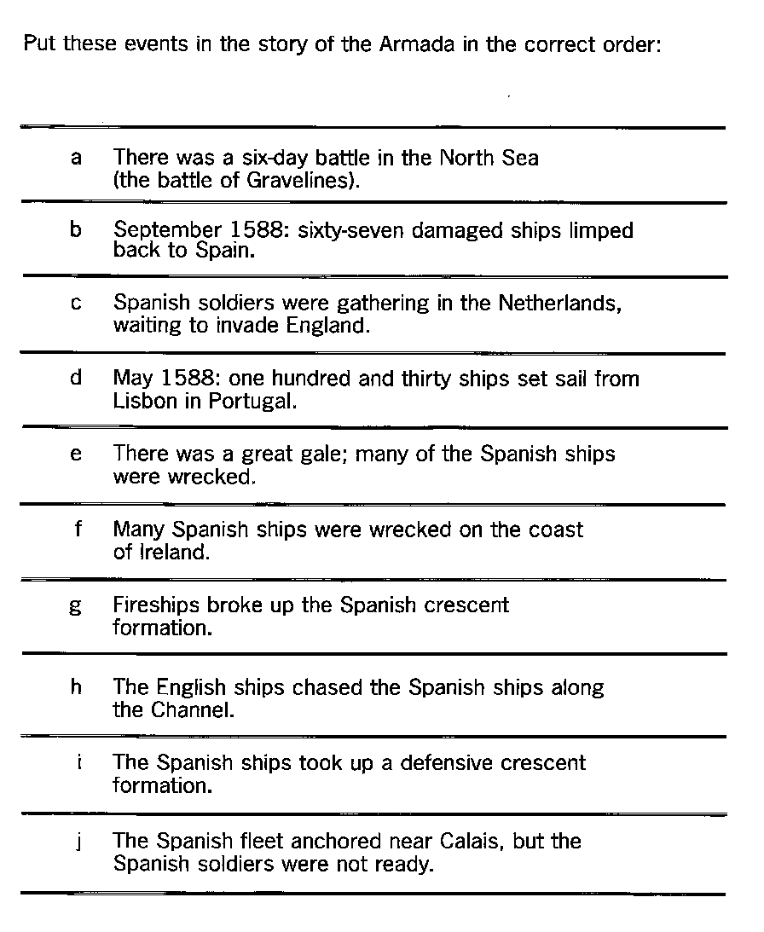
The Armada Game – the board

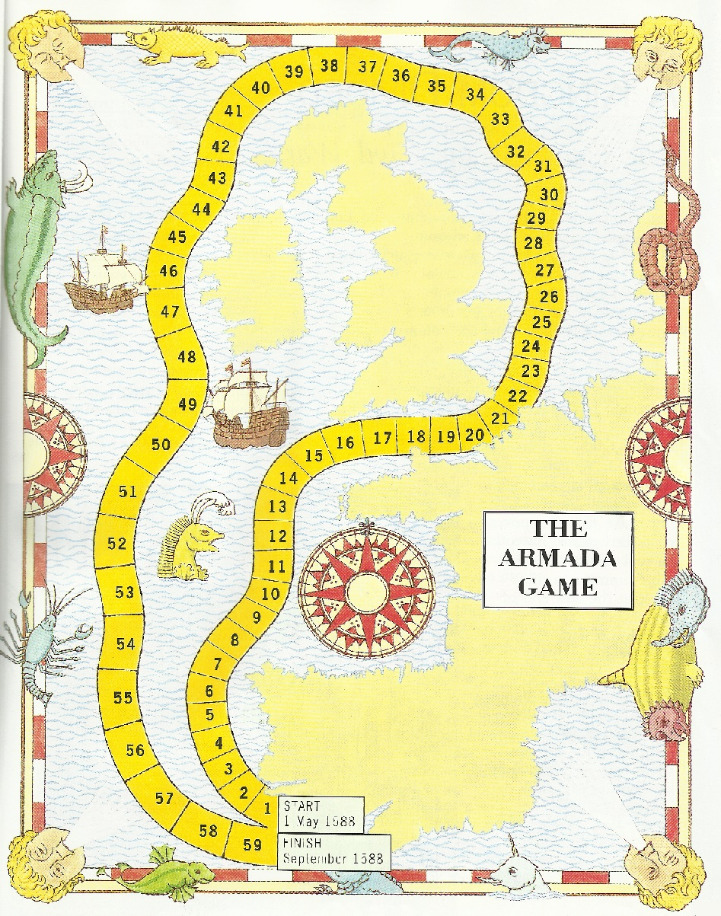
The Armada Game – the rules
Throw a six to start (organising an armada is a difficult task).
Throw the die, move your marker the correct number of spaces on the board, then follow the instructions given for the space on which you land. Keep a record of the number of ships you lose.

1 Last year, the English privateer Sir Francis Drake destroyed your storage barrels. Food goes rotten much faster in the new barrels. Move on ONE less space than the number you throw on the die for the rest of the game.
2 Ropes supplied by crooked Spanish merchants break easily when the wind rises. Lose TWO ships every time you throw a six for the rest of the game.
3 Admiral Medina Sidonia, who has never been to sea before, gets seasick. Miss a go.
4 FREE SAILING.
5 A violent storm in the Bay of Biscay. Go back to the start. (You must throw a six again to start.)
6 FREE SAILING.
7 Bad luck! An English ship spots you and races to warn the English. You lose the element of surprise: go back THREE spaces.
8 You hear that Spanish soldiers under the Duke of Parma have reached Calais. Move forward TWO spaces.
9 You hear that many of the Duke of Parma's men have died of disease. Move back TWO spaces.
10 FREE SAILING.
11 In England, warning beacons are lit. You had hoped that English Catholics would prevent this from happening. Miss a go.
12 FREE SAILING.
13 Strong winds and a game of bowls keep the English fleet in Portsmouth. Have an extra go.
14 You take up a crescent (half-moon) formation. It is much safer, but much slower. Move THREE spaces less than the number you throw on the die until you pass square number 23. (If you throw three or less, stay where you are.)
15 Powerful guns on your ships damage the English flagship. Move on ONE space.
16 One of your ships is destroyed by an explosion. Lose ONE ship.
17 Two ships in the crescent collide. Lose TWO ships.
18 The English are unable to break your formation. Move on TWO spaces.
19 The English attack. Although your ships beat them off, you have to slow down to keep formation. Throw the die and move back as many spaces as the number you throw on the die
20 You hear that the Spanish soldiers under the Duke of Parma will not be ready for a fortnight. Go back FIVE spaces.
21 Calais. You are not allowed to enter the port. Miss a go while you think what to do.
22 Calais. English `hellburners' (fireships) destroy your formation. Your ships flee in panic. Lose ONE ship and move forward TWO spaces.
23 FREE SAILING.
24 The English ships are constantly attacking. Lose TWO ships.
25 You run out of cannonballs and have to use muskets. Lose TWO ships.
26 One of your ships gets stuck on sandbanks. Miss a go.
27 FREE SAILING.
28 Although Medina Sidonia's flagship is attacked by three English warships, it manages to escape. Morale is boosted greatly. Move on TWO spaces.
29 FREE SAILING.
30 The English ships run out of ammunition and have to turn back. Move on TWO spaces.
31 FREE SAILING.
32 FREE SAILING.
33 The weather is worsening. Many ships are badly damaged. Lose FIVE ships.
34 Your fleet loses all contact in the bad weather. Go back SIX spaces.
35 The Great Storm. Without anchors, your ships are driven onto the rocks. Lose TEN ships.
36 The Great Storm continues. Lose TEN ships.
37 The Great Storm continues. Lose TEN ships.
38 FREE SAILING.
39 Your biscuits are mouldy and crawling with maggots. Your water is foul. Your men are dying. Lose TWO ships.
40 The ship's cow dies. You have to reach land and capture another one. Miss a go.
41 Torn sails slow you down. Move on TWO less spaces than the number you throw on the die for the rest of the game. (If you throw two or one, stay where you are.)
42 These are dangerous and unknown waters for you. Lose SIX ships on hidden reefs.
43 Badly damaged, their rudders broken, THREE ships are blown into the Atlantic and lost for ever.
44 FREE SAILING.
45 Your ships are now in such bad condition that any strong wind is disastrous. Throw the die three times. Lose THREE ships each time you throw a five or a six for the rest of the game.
46 FREE SAILING.
47 Men from one of your ships land in Ireland and disappear. There is a rumour that they have been eaten! Lose ONE ship.
48 On one ship the cockroaches swarm and alarm the helmsman. Not concentrating, he runs into a passing whale. The whale is a little startled, but the ship sinks. Lose ONE ship.
49 An epidemic of scurvy breaks out. Move back THREE spaces.
50 FREE SAILING.
51 On one ship the navigator is swept overboard while going to the toilet and is eaten by a shark. Lose ONE ship and miss two goes while you look for him.
52 The pump breaks on one ship, which sinks. Lose ONE ship.
53 FREE SAILING.
54 Heavy seas, lose THREE ships and move back FIVE spaces.
55 ONE ship overturns trying to 'go about' in heavy seas.
56 You are attacked by English sea dogs. Although you have no treasure, they burn ONE ship in a fit of temper when they find out.
57 FREE SAILING . . . and almost home.
58 Your sails are torn. Your ship has no rudder or anchor. Most of your men have died of thirst or scurvy. The ropes are breaking and the wood is worm-eaten. Go back to space 38.
59 One ship has sunk in the harbour mouth and other ships, without rudders, cannot avoid crashing into the wreck. Throw the die twice and lose as many ships as the total you throw.
60 HOME! . . . now work out your final score.

TO WORK OUT YOUR FINAL SCORE:
1 If you got home first, score 130 ships.
If you got home second, score 120 ships.
If you got home third, score 115 ships.
If you got home fourth, score 110 ships.
If you got home fifth, score 105 ships.
If you got home sixth, score 100 ships.
2 Then deduct from your total all the ships you lost during the game.
3 The player with the most ships left is the winner. (Philip finished with only 67 ships. Did you beat him?)

