Put the title Government in 18th century England in your exercise book.

Read the information on the webpage, then:

Task One:
1. Working with a partner or in a small group, study Source 1. Make a list of all the ways the candidates are trying to win the electors’ votes. Remember that there are TWO candidates shown in the painting.
2. Share your results with the rest of the class.

Task Two:
1. Working in a small group, do the worksheet: Find the Atrocity!
2. Discuss as a whole class:
How were elections in 18th century England different to elections today?
3. Write 400 words beginning: ‘Eighteenth century government was very different to modern Britain…’

Find the Atrocity!
What is the terrible tragedy, the evil event? Answer the clues, and the event will reveal itself in the middle column of the grid.
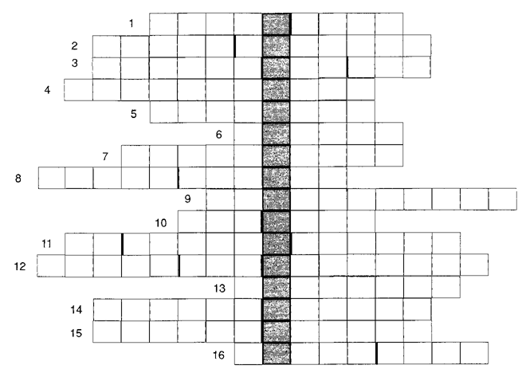

Clues
1. Read all about it! You had to pay up after 1819.
2. A paper spy-catcher.
3. He was paid to cause trouble – there's no twist.
4. Marchers who had nothing but their beds.
5. This put a rebellion in its place in 1817.
6. So many people died on 16 August 1819!
7. It cut off a king's head.
8. They were outlawed in 1799.
9. They were unfair acts to stop a get-together.
10. The government took a number of measures to prevent rebellion in 1819.
11. It seemed like the right place to wear your Sunday best.
12. What does a Manchester banner say?
13. Reformers who want to change Britain's roots.
14. It stops you going to prison without a trial.
15. He was stoned in 1817.
16. He had barely started speaking when the troops charged in.

