Put the title Feelings 2 – The Hero into your exercise book.

Study the information on the webpage, then:

Task One
1. Read the letter. Working with a partner, make sure you understand what it is saying – in particular:
- Why did Kelly give his pocket-book to a ‘Tommy’?
- What did he mean by ‘proved very childish?
- What did he mean by ‘acted like a drunken man’?
2. Try to work out the sequence of events on 27 March 1918.

Task Two
1. The feelings of Frank Kelly when he was wounded and thought he was dying were very different to those of Charles Yale Harrison in the previous lesson. Working in small groups, but then sharing your suggestions in a whole-class plenary, make inferences from the letter to suggest a list of all the feelings that Kelly experienced on 27 March 1918.
Write up your findings as a table, thus:
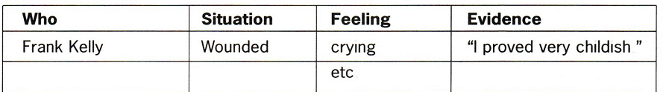
(You will be adding to this over the next few lessons.)

POSSIBLE SEQUENCE OF EVENTS ON 27 MARCH:
Here is a list that I would draw up with my students after they had done the exercise in Task 1.2:

