Put the title The General Strike of 1926 into your exercise book.

Study the information on the webpage, then:

Task One
1. In small groups or with a partner, discuss in detail what you can see in a number of photos; share your finding with other groups, until everyone has a detailed description of every photo. Invent a catchy ‘newspaper headline’ for each.
2. Cut up the events on worksheet B2. Put them into what seems like a sensible chronological order.
3. Taking a general overview, the course of the strike ran like this:
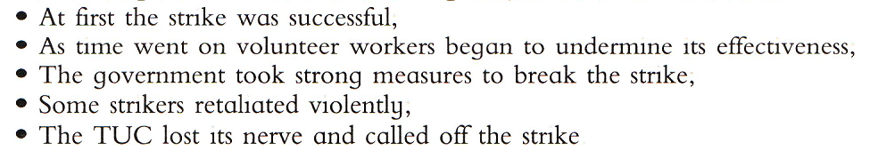
Does this help with question 2? Looking at your list, is there any event which strikes you as unusual/ incongruous? Why?
4. If you wished, using the ‘Further Facts’ factsheets linked from the webpage, it would be possible to write a factual narrative description of the General Strike (this would be a very low level skill). Make a list of the KEY FORMATIVE EVENTS – the events which were real key moments in the Strike.

Task Two
1. Look again at the photos. Which facts/events would you select to use if you were doing a special analysis/study within the Strike of:
- Stoppage and disruptions; the success of the Strike;
- Violence and how dangerous a constitutional threat the Strike was;
- The use of threat, coercion and force by the government;
- The factors contributing to the failure of the Strike;
- The propaganda war.
You can add other facts if you wish from the ‘Further Facts’ factsheets linked from the webpage
2. Using the facts you have gathered, write about one of these issues so as to EXPLAIN it. Use the word ‘so’. This is a high level skill.

ANSWER TO TASK ONE QUESTION 2
There is no absolutely correct answer but, using the ‘Further Facts’ factsheets linked from the webpage, it is possible to suggest a sensible order thus:
