The Cold War

In this module you will learn:
- FOUR causes of the Cold War [BARE].
- NINE events which caused the Cold War.
- FOUR decisions made at the Yalta Conference.
- TWO decisions and three disagreements at the Potsdam conference.
- The ‘salami tactics’ that brought Communists to power in Eastern Europe
- FIVE causes [CABAN] and FOUR results [CENA] of the Berlin crisis, 1948–9.
- FIVE ‘Berlin Airlift Facts’.
- FOUR causes of the Korean War [CJD-Kim].
- FIVE phases of the Korean War, 1950–53.
- FOUR ways Khrushchev brought a ‘thaw’ in the Cold War.
- THREE ways ‘peaceful co-existence’ worsened the Cold War.
- EIGHT countries in the Warsaw Pact.
- FIVE crises after 1955.
- FIVE causes, the events and FOUR results of the Hungarian uprising
- THREE reasons tension grew after 1957.
- The events and FOUR results of the U2 crisis.
- THREE causes, the events and FOUR results of the Berlin Wall
- THREE causes, the events and FOUR results of the Cuban Missiles Crisis.

You might do the following written work:
❒ A paragraph on ‘What was the Cold War?’
❒ An essay: ‘Were the Yalta and Potsdam conferences different?’
❒ A spidergram of the factors bringing Communists to power in eastern Europe, 1945–48.
❒ An essay: ‘Why had the superpowers become suspicious of each other by March 1946, when Churchill made his Fulton speech?’
❒ Notes on events: ‘Truman Doctrine – Marshall Plan’.
- Written notes on the causes of the Berlin Blockade.
- A written description of the Berlin Crisis, Jan 1948–12 May 1949.
- A spidergram of why the Berlin blockade failed.
- Written notes on the causes of the Korean War.
❒ An essay on the events of the Korean War.
❒ Notes on how Khrushchev brought a thaw in the Cold War, and how he made it worse.
❒ An essay: ‘Did superpower relations improve after 1953?’
❒ Notes on the Polish Riots of 1956.
❒ A mini-essay: ‘Why was there a revolution in Hungary in 1956?’
❒ Notes on the events and results of the Hungarian Revolution.
- A mini-essay: ‘The events which led to the Berlin Wall 1958–61.’
- Notes on the results of the Berlin Wall.
- A mini-essay: ‘Why was there a Cuban Missile Crisis in 1962.’
- Notes on the events and results of the Cuban Missile Crisis.

Have you read:
❒ N deMarco and R Radway, The Twentieth Century, pages 184–191.
❒ T Rea and J Wright, International Relations, chapter 7.
❒ Christopher Culpin, Making History, pages 185–192.
❒ JF Aylett, The Cold War and After, pages 2–17.
❒ James Mason, Modern World History to GCSE, pages 56–77.
❒ Tony Howarth, Twentieth Century History, pages 235–244.
New Words  Allies: countries working together.  Communists: believe that industry should be state-owned.  Soviet Union: the Union of Soviet Socialist Republics – the USSR –– i.e. communist Russia.  Dictator: a ruler who has total power.  Stalin  Capitalists: believe that property and industry should be privately owned.  Democracy: where the people can elect their own government.  Truman  Churchill  Tasks  Write a paragraph to explain the meaning of the term ‘Cold War’. |  | From Hot War to Cold War  During the Second World War, Britain and the USA were allies of the Soviet Union, fighting together against Germany. After the war, they became enemies.  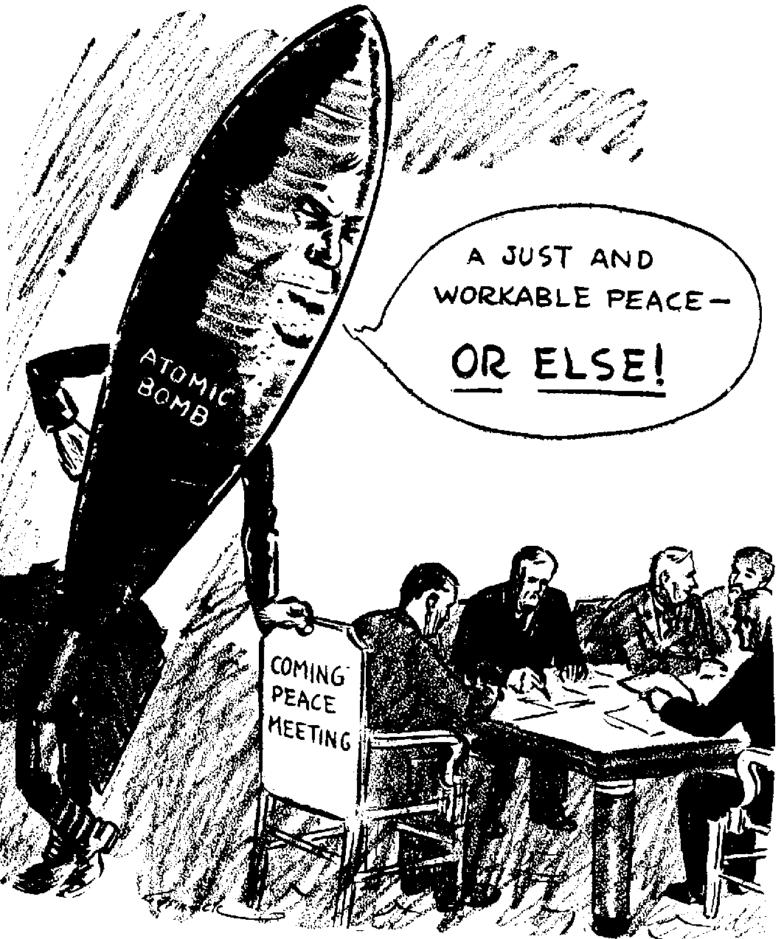  After Hiroshima, and particularly after 1949 when Russia developed the atomic bomb, politicians realised that another ‘hot war’ would kill all humankind – war would be MAD (mutually assured destruction).  So they stopped short of war – the ‘cold war’. They didn’t declare war. But they did everything to oppose each other short of war.  It was called the ‘cold war’. It lasted until 1989.

Causes of the Cold War  1 Beliefs  - The Soviet Union was a Communist country, ruled by a dictator, who cared little about human rights.  - The USA was a capitalist democracy which valued freedom.  - Aims  - Stalin wanted huge reparations from Germany, and a ‘buffer’ of friendly states to protect the USSR from being invaded again.  - Britain and the USA wanted to protect democracy, and help Germany to recover. They were worried that large areas of eastern Europe were falling under Soviet control.  - Resentment about History  - The Soviet Union could not forget that in 1918 Britain and the USA had tried to destroy the Russian Revolution. Stalin also thought that they had not given him enough help in the Second World War.  - Britain and the USA could not forget that Stalin had signed the Nazi-Soviet Pact with Germany in 1939.  - Events  - Neither side trusted each other. Every action they took (see Source B) made them hate each other more.  Who Caused the Cold War?  Russian historians blamed Churchill (the British Prime Minister) and Truman (the American president, 1945–1953). They said Truman and Churchill wanted to destroy the USSR, which was just defending itself.  At first, western writers blamed the Soviet Union. They said Stalin was trying to build up a Soviet empire. Later, however, some western historians blamed the USA. They said Truman had not understood how much Russia had suffered in the Second World War.  Nowadays, historians think BOTH sides were to blame – that there were hatreds on both sides.  Source A  It is useless to try to discover who made the first move to break the alliance. It is impossible to trace the first ‘broken promise’.  Written by the historian Isaac Deutscher, Stalin (1969). |  |  |  |  |  |  | Source B:  Events which caused the Cold War  Yalta Conference (Feb 1945)  Potsdam Conference (Jul 1945)  Salami tactics (1945–48)  Fulton Speech (Mar 1946)  Greece (Feb 1947)  Truman Doctrine (Mar 1947)  Marshall Plan (Jun 1947)  Cominform (Oct 1947)  Czechoslovakia (Feb 1948)  Tasks  Write a paragraph to explain the meaning of the term ‘Cold War’.  Copy, then learn the five causes and nine events which caused the Cold War, so that you know them ‘off by heart’.  For each of the five causes, explain how it might have caused relations between the USA and the USSR to become tense.  Working in twos, one pupil plays the part of a Russian historian, the other a western writer of the 1950s. Talk about causes 1–4, the ‘Russian historian’ arguing that the Cold War was America’s fault, and the ‘western writer’ saying that it was Russia’s.
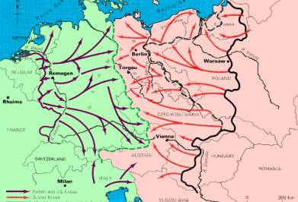  The Big Three during the War  During the War, Britain and the USA were allies of the Soviet Union, but the only thing that united them was their hatred of Germany.  In 1945, the Big Three held two conferences – at Yalta (February) and Potsdam (July) – to try to sort out how they would organise the world after the war. It was at these conferences that the tensions between the two sides became obvious.  Yalta (Feb 1945)  On the surface, the Yalta conference seemed successful.  The Allies agreed:  - Russia would join the United Nations.  - divide Germany into four ‘zones’, which Britain, France, the USA and the USSR would occupy after the war.  - bring Nazi war-criminals to trial.  - set up a Polish Provisional Government of National Unity 'pledged to the holding of free and unfettered elections as soon as possible'.  - help the freed peoples of Europe set up democratic and self-governing countries by helping them to (a) maintain law and order; (b) carry out emergency relief measures; (c) set up governments; and (d) hold elections (this was called the 'Declaration of Liberated Europe').  - set up a commission to look into reparations.  But, behind the scenes, tension was growing. After the conference, Churchill wrote to Roosevelt that ‘The Soviet union has become a danger to the free world.’  Tasks  Source B shows the ‘Big Three’ smiling. Does this prove that Britain, Russia and America were friends?  Write two reports of the Yalta Conference: one for the British newspapers, the other for the British government. |  |  |  |  |  |  | Did you know?  Churchill was so worried about Soviet domination of eastern Europe that he tried to get the British armies to advance faster. In 1944, he dropped British paratroopers behind enemy lines at Arnhem – but they were cut off and defeated by the Germans.  This story was told in the film, A Bridge Too Far.  ⬅ Source A  The arrows show the Allied armies advancing into Germany in 1945 – the British and Americans from the west, the Russians from the east. Notice the large areas of eastern Europe which fell under the control of Russia.  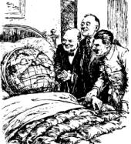  ⬆ Source B  A British cartoon of 1945. Churchill, Roosevelt (USA) and Stalin are shown as doctors, working together to heal the world. Look at the faces of the ‘Big Three’; what do you notice?  Tasks  Describe the events and decisions of the Yalta and Potsdam Conferences. Were they different?  Using page 5, especially Sources D and E, explain why Potsdam was less successful than Yalta.
Source D  The Russians only understand one language - ‘how many armies have you got?’ I’m tired of babying the Soviets.  President Truman, writing in January 1946  Source E  What is surprising about the fact that the Soviet Union, worried about its future safety, wants governments friendly to it in Finland, Poland and Romania?  Stalin, writing in March 1946  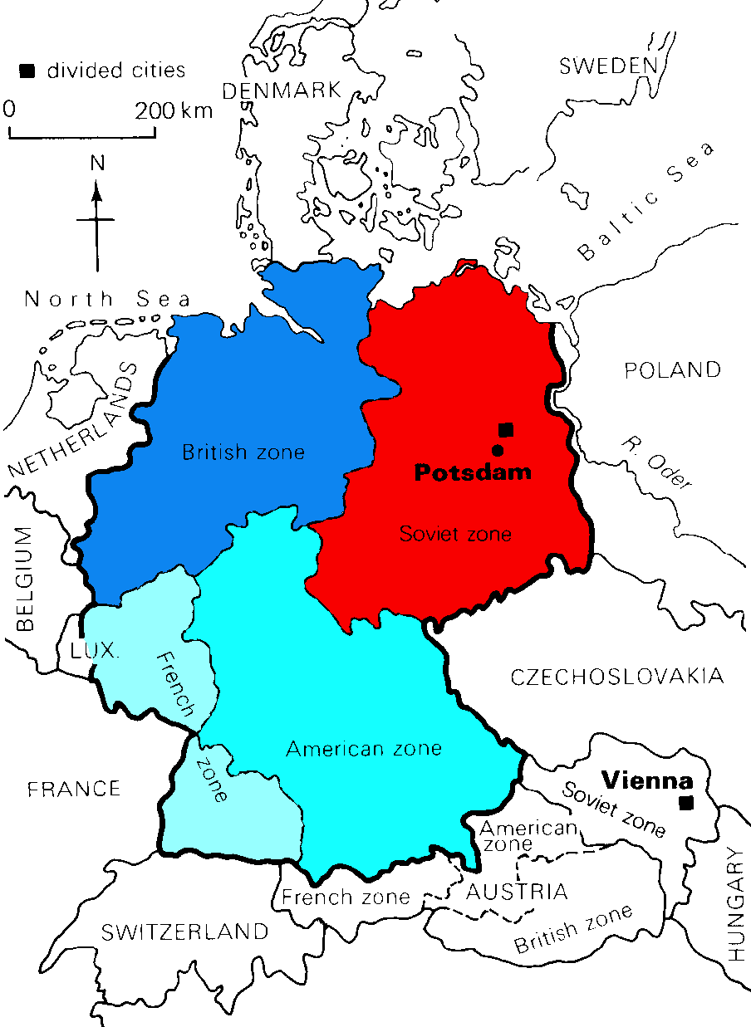  A map of how Germany was divided into zones.  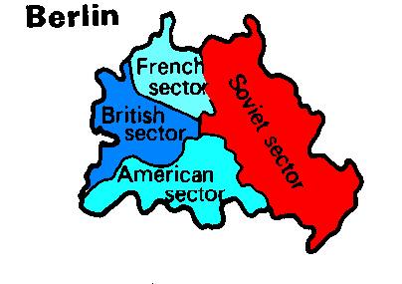  A map of how Berlin was divided into zones. |  |  | ⬅ Source C  The thief labelled ‘Russia’ is caught stealing a bag labelled ‘territorial grabs’.  ‘It’s alright – he’s with me’, Stalin assures Roosevelt, who meekly answers: ‘Oh, OK’.  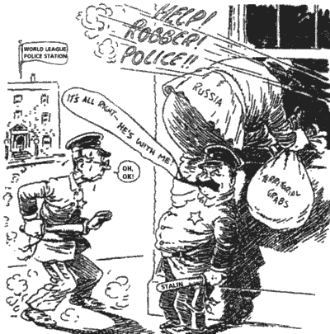  Potsdam (July 1945)  At Potsdam, the Allies decided the post-war peace – Potsdam was the Versailles of World War II  America had a new president, Truman, who was determined to ‘get tough’ with the Russians. Also, when he went to the Conference, Truman had just learned that America had tested the first atomic bomb. It gave the Americans a huge military advantage over everyone else. Moreover, in March 1945, Stalin had invited the non-Communist Polish leaders to meet him, and arrested them.  So, at Potsdam, the arguments came out into the open.  The Conference agreed the following Protocols:  - to set up the four ‘zones of occupation’ in Germany. The government and laws and education ‘shall be controlled to eliminate Nazi and militarist doctrines and to make possible the development of democratic ideas.  - to bring Nazi war-criminals to trial.  - to recognize the Polish Provisional Government of National Unity and hold 'free and unfettered elections as soon as possible'.  - Russia was allowed to take reparations from the Soviet Zone, and also 10% of the industrial equipment of the western zones as reparations. America and Britain could take reparations from their zones if they wished.  But in fact the Allies had disagreed openly about:  1. the details of how to divide Germany.  2. the size of reparations Germany ought to pay.  3. Russian policy in eastern Europe.  Source D  In this ‘marriage of convenience’, the thought that a divorce was inevitable had been in the mind of each partner from the beginning.  Written by the historian Isaac Deutscher, Stalin (1969).  Tasks  Looking at the information on this spread, when do YOU think the Cold War started? Read Source F; when did Deutscher think it started?
 | Salami tactics: the Soviet take-over of eastern Europe
 | New Words  sinister: frightening, in an evil way.  totalitarian: where the government has total power over the people.  imperialistic: wanting to build an empire. Communists used it as an abuse-word to describe the western powers.  During 1946–47, Stalin made sure that Communist governments came to power in all the countries of eastern Europe (the countries which the Soviet Union had conquered in 1945).  The Communist description of this process was ‘slicing salami’ – gradually getting rid of all opposition, bit-by-bit (see Source A). In this way, Russia gained control of:  - Albania (1945) – the Communists took power after the war without opposition  - Bulgaria (1945) – a left-wing coalition gained power in 1945; the Communists then executed the leaders of all the other parties.  - Poland (1947) – a coalition government took power in 1945, but the Communists forced the non-Communist leaders into exile.  - Hungary (1947) – see Source A.  - Romania (1945–1947) – a left-wing coalition was elected in 1945; the Communists gradually took over control.  - Czechoslovakia (1945–48) – a left-wing coalition was elected in 1945. In 1948, the Communists banned all other parties and killed their leaders.  - East Germany (1949) – the Russian turned their zone of Germany into the German Democratic republic in 1949.  Tasks  Read Source A, and make a spidergram showing all the factors that helped Communists take power in the countries of eastern Europe.  Explain how the case of Hungary on Source A illustrates ‘salami tactics’. |  |  |  | Source A  Hungary was invaded by the Russians, and in 1945 the allies agreed that Russian troops should stay there. Stalin allowed elections, and the non-communists won a big majority. However, some communists were elected, led by a pro-Russian called Rakosi.  Rakosi now started demanding that groups which opposed him should be banned. If not, he hinted, the Russians would take over the country. Then he got control of the police, and started to arrest his opponents. He set up a sinister and brutal secret police unit, the AVH. Soon Rakosi had complete control over Hungary.  Rakosi’s work was typical of what was happening all over eastern Europe.  The historian Jon Nichol, writing in 1990  ⬇ Source B  Russia saw it as protecting herself from future attack. The West saw it as empire-building.  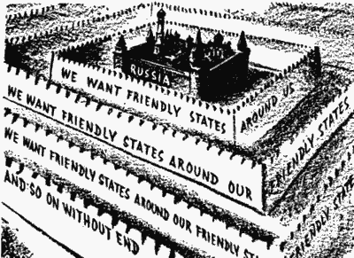
 | Churchill’s Fulton Speech  On 5 March 1946, Winston Churchill gave a speech at Fulton in America. He said ‘a shadow’ had fallen on eastern Europe, which was now cut off from the free world by ‘an iron curtain’. Behind that line, he said, the people of eastern Europe were ‘subject to Soviet influence . . . totalitarian control [and] police governments’.  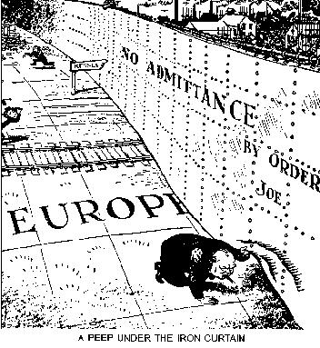 |  |  |  | Source C  Mr Churchill has called for a war on the USSR.  Stalin, writing in the Russian newspaper Pravda on 13 March 1946.  Source D  . . . the Cold War set in. Churchill had given his famous speech in Fulton urging the imperialistic forces of the world to fight the Soviet Union. Our relations with England, France and the USA were ruined.  Nikita Khrushchev, writing in 1971. In 1946 he was a member of the Soviet government.  ⬅ Source E  A British cartoon of 1946. In fact, the ‘iron curtain’ was a 2,000-kilometre line of barbed wire, look-out posts and road blocks.  Tasks  Read Sources C and D. Explain why Churchill’s speech was a turning point in the history of the Cold War.  Did Churchill cause the Cold War?

Essay!
[use this essay frame to write the following essay, using pages 2–6]
Why had the Superpowers become suspicious of each other by
March 1946, when Churchill made his important speech at Fulton?

They became suspicious of each other because they had different beliefs. The USA. . . . . . . . . . The USSR . . . . . . . . . . This caused suspicion because . . . . . . . . . .

History made the USA and the USSR suspicious of each other. The Soviet Union . . . . . . . . . . The USA . . . . . . . . . . This caused suspicion because . . . . . . . . . .

Both the USA and the USSR had very different aims. The USA . . . . . . . . . . The USSR, however, . . . . . . . . . . This caused suspicion because . . . . . . . . . .

Finally, because neither side trusted each other, events made them hate each other more.
- The Yalta Conference (Feb 1945) caused problems because . . . . . . . . . .
- The Potsdam Conference (Jul 1945) . . . . . . . . . .
- Also, salami tactics (1945–48) caused suspicion because . . . . . . . . . .

New Words  doctrine: a belief.  Congress: the American ‘parliament’.  Czechoslovakia  aggressor: someone who starts a quarrel.  Containment: holding something in – stopping the USSR growing.  Source A  Every nation must choose between different ways of life . . . We must help free peoples to work out their own destiny in their own way.  President Truman, speaking in March 1947.  Source B  This ‘American duty’ is just a smokescreen for a plan of expansion . . . They try to take control of Greece by shouting about ‘totalitarianism’  The Russian newspaper Izvestia, March 1947. |  |  |  |  | Opinion:  Churchill’s speech did not start the Cold War, but he was the first person to stop pretending to be friends with Russia. Thus, his Fulton speech was the start of the Cold War; after it, America and Russia got into a number of conflicts.  Greece  By 1946, Greece and Czechoslovakia were the only countries in eastern Europe that weren’t Communist. Even in Greece, the government, which was being supported by British soldiers, was having to fight a civil war against the Communists.  In February 1947, the British told Truman they could no longer afford to keep their soldiers in Greece. President Truman stepped in. The USA paid for the British soldiers in Greece.  The Truman Doctrine  In the 1930s, Americans had kept out of Europe’s business.  Now, in March 1947, Truman told Americans that it was America’s DUTY to interfere (Source A). His policy towards the Soviet Union was one of ‘containment’ – he did not try to destroy the USSR, but he wanted to stop it growing any more. This was called the ‘Truman Doctrine’.
Source C ➔  This Russian cartoon shows the Greek government being ‘helped’ by America. | 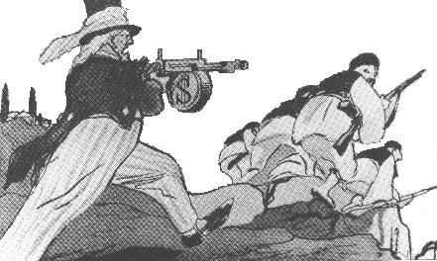
The Marshall Plan  In June 1947, the American general George Marshall went to Europe. He said every country in Europe was so poor that it was in danger of turning Communist! Europe was ‘a breeding ground of hate’. He said that America should give $17 billion of aid to get Europe’s economy going.  Cominform  The Soviet Union hated Marshall aid (see Sources D and E). Stalin forbade Communist countries to ask for money. Instead, in October 1947, he set up Cominform. Every Communist party in Europe joined. It allowed Stalin control of the Communists in Europe.  Czechoslovakia  At first, the American Congress did not want to give the money for Marshall Aid. But then, in February 1948, the Communists took power in Czechoslovakia.  Congress was scared, and voted for Marshall Aid on 31 March 1948.  Tasks  Using the dates in bold, make notes, in chronological order, on the events from February 1947 to 31 March 1948.  Read Source A. Talk about the events in your list – as though you were an American.  Now read Sources B–E. Describe the same events – as though you were a Russian Communist  Did the Truman Doctrine cause the Cold War?  What was the first event of the Cold War?  Work out an argument that the creation of Cominform was the first event of the Cold War. |  |  |  |  | Source D  The ruling gang of American imperialists has taken the path of open expansion, of enslaving weakened capitalist countries. It has hatched new war plans against the Soviet Union. Imitating Hitler, the new aggressors are using blackmail.  GM Malenkov, a Soviet politician, speaking in 1947.  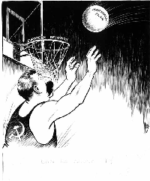  ⬆ Source E  Communists in Germany oppose Marshall Aid.  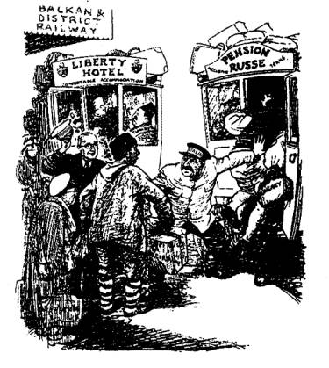⬆ Source F  A British cartoon shows Truman and Stalin as two taxi-drivers trying to get customers.
The Berlin Blockade, 1948–49  The USSR had already disagreed with Britain and the USA at Potsdam (July 1945, see page 5) about what should be done with Germany. Germany had been split into four zones. Berlin, in Russia’s zone, was also split into four zones.  What caused it?  - Cold War  was just getting started (e.g. Czechoslovakia, March 1948)  2. Aims  Stalin wanted to destroy Germany – Britain and the USA wanted to rebuild Germany.  3. Bizonia  The Russians were taking German machinery back to the USSR. In January 1948, Britain and the USA joined their two zones together to try to get German industry going. They called the new zone Bi-zonia (‘two zones’).  American Aid  Congress voted for Marshall Aid on 31 March 1948. Immediately, the Russians started stopping and searching all road and rail traffic into Berlin.  New Currency  On 1 June, America and France announced that they wanted to create the new country of West Germany; and on 23 June they introduced a new currency into ‘Bizonia’ and western Berlin. The next day the Russians stopped all road and rail traffic into Berlin – Stalin was trying to force the USA out of Berlin.  Source A  [The Americans had introduced a new currency into Berlin.]  Old money flooded into the Soviet Zone. Some restrictions were placed on links between Berlin and western zones, but the Soviet side was ready to supply food to all Berlin.  Yet every day 380 American planes flew into Berlin. It was simply a propaganda move intended to make the cold war worse.  From a Russian history book. |  |  |  |  |  |  | New Words  Blockade: a siege.  Bizonia  Currency: money.
Source B:  Airlift Facts  - The blockade lasted 318 days (11 months).  - In the winter of 1948–49 Berliners lived on dried potatoes, powdered eggs and cans of meat. They had 4 hours of electricity a day.  - 275,000 flights carried in 1½ million tons of supplies. A plane landed every 3 mins.  - On 16 April 1949, 1400 flights brought in 13,000 tons of supplies in one day – Berlin only needed 6,000 tons a day to survive.  - The USA stationed B-29 bombers (which could carry an atomic bomb) in Britain. |  |  | What happened?  The American Army wanted to fight its way into Berlin – that would have caused a war. Instead, Truman decided to supply Berlin by air (see Source B)  The situation was bad at first, but things got better as the blockade went on. On 12 May 1949, Stalin re-opened the borders.  What were the Results?  - Cold War got worse  It almost started an all-out war.  2. East and West Germany  Germany split up. In May 1949, America, Britain and France united their zones into the Federal Republic of Germany (West Germany). In October 1949, Stalin set up the German Democratic Republic (East Germany) .  3. NATO and the Warsaw Pact  In 1949, the western Allies set up NATO (North Atlantic Treaty Organisation) as a defensive alliance against Russia. NATO countries surrounded Russia; in 1955, the Soviet Union set up the Warsaw Pact – an alliance of Communist states.  - Arms Race  After Berlin, the USA and the USSR realised that they were in a competition for world domination. They began to build up their armies and weapons.  Tasks  Copy the five causes of the Berlin Crisis.  The Berlin blockade and airlift was one of the first episodes of the Cold War. Write an essay to describe what happened.  Start the story in Jan 1948, and finish it on 12 May 1949.  Working as a whole class, draw a spidergram to show all the reasons why the Berlin blockade failed.
The Korean War, 1950–53  The Korean War was the time when the Cold War became a global conflict.  What caused it?  President Truman was interested in the Far East:  - Cold War: Truman realised the USA was in a competition for world domination with the USSR. Europe was not the only place where Communists were coming to power. In the Far East, too, they were getting powerful – China turned Communist in 1949.  - Japan: Truman was worried that, in the end, the Communists would capture Japan.  - Domino theory: Truman believed that, if one country fell to Communism, then other would follow, like a line of dominoes.  Stalin, also, was involved in the Far East:  - Kim II Sung visited Stalin. In 1949, he persuaded Stalin that he could conquer South Korea. Stalin was worried that America would get involved, but he gave his agreement. Kim II Sung also went to see Mao Tse Tung, the leader of China, to get his agreement.  In 1950, Syngman Rhee boasted that he was going to attack North Korea. It was a good enough excuse – the North Koreans invaded South Korea.  This started the Korean War.  The war had FIVE phases. |  |  |  |  |  |  | Did you know?  In 1945, Korea was freed from the Japanese. The country was split in half at the 38th parallel.  North Korea  - (led by Kim II Sung) was Communist.  South Korea  - (led by Syngman Rhee) was capitalist.  The two countries hated each other.  Source B  Asia is where the communist conspirators have decided to make their play for global conquest. If we lose this war, the fall of Europe is inevitable. There is no choice but victory.  The US General MacArthur, speaking in 1950.  New Words  global: whole world  38th parallel: a line of latitude on the map.  Kim II Sung  Syngman Rhee  Mao Tse Tung

The Events of the War, 1950–53

I | June 1950  The North Koreans attacked.  They were very successful.  They captured most of South Korea. | 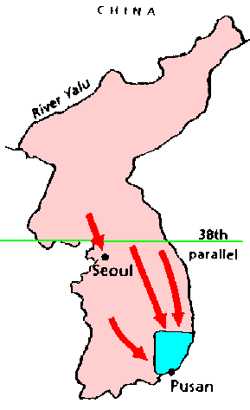
II  I | July 1950  The Americans were alarmed (see Source B).  They persuaded the United Nations to support South Korea.  The American Army, led by General MacArthur, went to Korea, drove back the North Koreans and recaptured South Korea. It invaded North Korea.  It advanced as far as the Chinese border. | 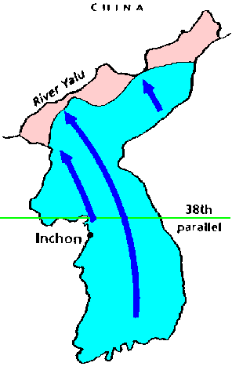
III | October 1950  Now the Chinese were alarmed.  They attacked MacArthur, and drove the Americans back.  They recaptured North Korea, and advanced into South Korea. | 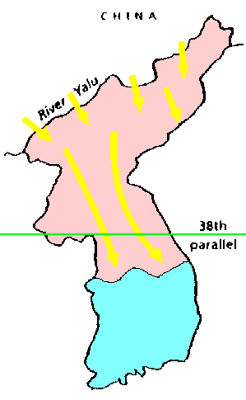
IV | February 1951  The Americans landed more troops.  They drove the Chinese back (the Chinese lost 200,000 men). | 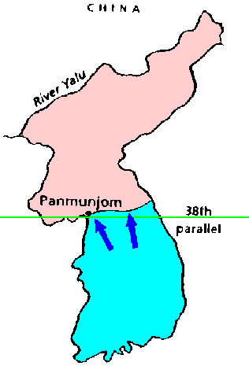
V | March 1951 – 1953  MacArthur reached the 38th parallel in March 1951.  Truman told MacArthur to stop.  MacArthur was sacked when he publicly criticised Truman’s order.  In 1953, Eisenhower became American president. He made peace.

Tasks

Look at Source B. Why was Korea so important for the Americans?

Write notes on the causes of the Korean War.

Write an essay to describe the main events of the Korean War, 1950–53.
Revision Questions

- Who was Prime Minister of Britain in 1945?
- Who was president of the USA in February 1945?
- Who became president of the USA in 1945?
- Who was leader of Russia in 1945?
- What is a ‘cold war’?
- List FOUR causes of the Cold War?
- What do Communists believe?
- The USA is a ‘capitalist democracy’. What do these words mean?
- Name two historical complaints that Stalin had against Britain and the USA.
- What could Britain and the USA not forgive Stalin for (from 1939)?
- Give TWO things that Stalin wanted from the peace.
- What worried Britain and the USA about Stalin’s plans?
- When did Russia develop the atomic bomb?
- List NINE events leading up to the Cold War, Feb 1945 to Mar 1948.
- Give FOUR things agreed at Yalta.
- Explain TWO reasons why the Potsdam Conference was less successful than Yalta.
- Name THREE things that the ‘Big Three’ disagreed about at Potsdam.
- What were ‘salami tactics’?
- Was is ‘totalitarianism’?
- Was does the word ‘imperialistic’ mean?
- What was Churchill’s Fulton speech (5 March 1946) about?
- Why did Britain keep soldiers in Greece after the Second World War had finished?
- What happened when the British could no longer afford to keep soldiers in Greece?
- What did the Truman Doctrine say?
- Why did Marshall propose the Marshall Plan?
- How much aid did the Marshall Plan want to send to Europe?
- Which country turned Communist in March 1948?
- What rival to Marshall Aid did Stalin set up in 1947?
- Give FIVE causes of the Berlin blockade.
- How long did the blockade last?
- How did the US and Britain supply the Berliners?
- List FOUR results of the blockade.
- What rival alliance to NATO did the USSR set up in 1955?
- Why was the Korean War important in the history of the Cold War?
- Name the ruler of North Korea in 1950.
- Name the ruler of South Korea in 1950.
- List THREE reasons why Truman was interested in the Far East.
- When did China turn Communist?
- Whose agreement to invade South Korea did Kim II Sung seek?
- What excuse did Kim II Sung have for attacking South Korea?
- Who was winning the war at its start in June 1950?
- Who led the UN forced which landed in July 1950?
- Why did the Chinese enter the war?
- How many Chinese soldiers died in the war?
- Why was MacArthur sacked?

/75

Q  Imagine a class with a really tough and nasty teacher. After a while, that teacher leaves, and a more gentle, reasonable teacher takes over. Will behaviour in the class get better, or worse?  Stalin died in 1953. He was hated all over eastern Europe. When they heard he was dead, people in East Berlin rioted.  After a short struggle for power, Khrushchev became the new ruler in Russia.  Khrushchev  At first, the western powers hoped that Khrushchev would be the start of a ‘thaw’ in the Cold War.  1. Khrushchev often met western leaders at ‘summit’ meetings.  2.. Stalin had made all Communist countries do what he wanted – and he had fallen out with President Tito of Yugoslavia. But in 1955 Khrushchev went to Yugoslavia, telling Tito that ‘there are different roads to communism’. Western leaders thought he would no longer insist that all communist countries take orders from Russia.  3. In a speech in 1956, Khrushchev attacked Stalin, saying that Stalin was a murderer and a tyrant. Khrushchev began to ‘de-stalinise’ Russia. Political prisoners were set free and Beria (Stalin’s Chief of Secret Police) was executed.  4. Khrushchev said that he wanted ‘peaceful  co-existence’ with the West. Western leaders hoped this meant the end of the Cold War.  Source A  You do not like Communism. We do not like capitalism. There is only one way out – peaceful co-existence.  Khrushchev speaking on a visit to Britain in 1956.  Source B  We may argue. The main thing is to argue without using weapons.  Khrushchev speaking in 1959.  Peaceful Co-existence  If the rulers of the West hoped that there would be an end to the Cold War, they were disappointed.  1. ‘De-stalinisation’ did not mean a change back to capitalism, or freedom from Russia. When communist countries went too far in their reforms, Khrushchev sent in the Red Army to stop them.  2. By ‘peaceful co-existence’, Khrushchev really meant ‘peaceful competition’. He started to build up Russian power:  - He visited countries like Afghanistan and Burma and gave them economic aid if they would support Russia.  - Russia began the ‘space race’ with the America. In 1957 Russia launched Sputnik the first satellite. In 1961 Yuri Gagarin became the first astronaut to orbit the earth.  - Russia began an ‘arms race’ with America. In 1953, Russia got the hydrogen bomb.  - Khrushchev set up the Warsaw Pact – a military alliance of Communist countries – to rival NATO.  3. Faced by this, America became just as aggressive:  - In America, Senator McCarty led a ‘witch-hunt’ for ‘Communists’ in America (e.g. Charlie Chaplin was accused of being a Communist.)  - America had an ‘arms race’ with Russia. In 1955, NATO agreed to a West German Army of ½ million men (this led to the formation of the Warsaw Pact).  - The Americans used U2 planes to spy on Russia.  As a result, the period 1955–1963 was the time of GREATEST tension in the Cold War. |  | New Words  summit: meeting of the major world powers.  destalinisation: dismantling Stalin’s tyranny.  Co-existence: living together.  capitalism: western system of a free economy.  economic aid: money given to a country to help build up its economy.  Did you know?  Even though he was a poorly-educated peasant, Khrushchev had insight and a good turn of phrase. He once said that Communism and capitalism would only agree ‘when shrimps learned to whistle’.  Source C  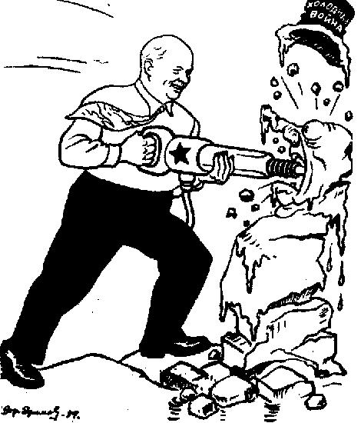This Russian cartoon shows Khrushchev destroying the Cold War.  Task  Make notes on the ways Khrushchev seemed to improve the Cold War.  Source D  EIGHT Countries in the Warsaw Pact:  - USSR  - Albania  - Bulgaria  - Czechoslovakia  - East Germany  - Hungary  - Poland  - Romania.  Source E  Crises after 1955:  1956 Poland  1956 Hungary  1960 U2 crisis  1961 The Berlin Wall  1962 Cuban Missile Crisis  Did you know?  Khrushchev was NOT a gentle easy-going man; he had been Stalin’s right-hand man –  Stalin had used him to run the terror purges after World War II. Khrushchev loved to argue. This often caused tension between leaders.  Task  Make notes on the ways Khrushchev made the Cold War worse.

In 1956, Khrushchev faced crises in two countries which were destalinising.  Poland  In Poland, a number of political prisoners were set free. At the same time, a bad harvest led to unrest.  Railway workers led a protest of people calling for ‘Cheap Bread’ and ‘Higher Wages’. When the police shot some of the marchers, there was a riot. Government officials were killed. Mr Gomulka, (who had been in prison) took power.  Khrushchev sent Russian troops into Poland to put down the rebels. But he left Gomulka in power – Gomulka continued the process of destalinisation, but he kept Poland loyal to Russia and the Warsaw Pact.  Hungary – Causes  The basic cause of the Hungarian revolution was that the Hungarians hated Russian communism:  1. Poverty  Hungarians were poor, yet much of the food and industrial goods they produced was sent to Russia.  2. Russian Control  The Hungarians were very patriotic, and they hated Russian control – which included censorship, the vicious secret police (AVH) and Russian control of what the schools taught.  3. Catholic Church  The Hungarians were religious, but the Communist Party had banned religion, and put the leader of the Catholic Church in prison.  4. Help from the West  Hungarians thought that the United Nations or the new US president, Eisenhower, would help them.  5. Destalinisation  When the Communist Party tried to destalinise Hungary, things got out of control. The Hungarian leader Rakosi asked for permission to arrest 400 trouble-makers, but Khrushchev would not let him.  Hungary – Events  On 23 October, there were riots of students, workers and soldiers. They smashed up the statue of Stalin, and attacked the AVH and Russian soldiers.  On 24 October, Imre Nagy took over as Prime Minister. He asked Khrushchev to take out the Russian troops.  On 28 October, Khrushchev agreed, and the Russian army pulled out of Budapest.  29 October – 3 November: The new Hungarian government introduced democracy, freedom of speech, and freedom of religion (the leader of the Catholic Church was freed from prison). He also announced that Hungary was going to leave the Warsaw Pact.  4 November: At dawn, 1000 Russian tanks rolled into Budapest. By 8.10 am they had destroyed the Hungarian army and captured Hungarian Radio – its last words broadcast were ‘Help! Help! Help”!’ Hungarian people – even children – fought them with machine guns. 27,000 people were killed.  Khrushchev put in Janos Kadar, a supporter of Russia, as Prime Minister.  Source C  We are quiet, not afraid. Send the news to the world and say it should condemn the Russians. The fighting is very close now and we haven’t enough guns. What is the United Nations doing? Give us a little help. We will hold out to our last drop of blood. The tanks are firing now. . .  The last message – a telex from a newspaper journalist – from Hungary.  Hungary – Results  1. 200,000 Hungarian refugees fled into Austria.  2. Russia stayed in control behind the Iron Curtain – no other country tried to get rid of Russia troops until Czechoslovakia in 1968.  3. People in the West were horrified – many British Communists left the Communist Party.  4. The West realised it could do nothing about the Iron Curtain countries – but this made Western leaders more determined to ‘contain’ communism. |  | New Words  patriotic: loving your country.  censorship: where the government controls what the newspapers/ radio etc. say.  telex: an early form of fax, connecting typewriters down a telephone line.  Task  Make notes on the ‘The Polish riots of 1956’.  Task  Prepare a 15-minute essay: ‘Why was there a revolution in Hungary in 1956’.  Source A  There were FIVE reasons why Khrushchev acted harshly in Hungary:  - Nagy’s decision to leave the Warsaw Pact was the last straw – Russia was determined to keep its ‘buffer’ of states.  - China asked Russia to act to stop Communism being damaged.  - Nagy had obviously lost control; Hungary was not destalinising – it was turning capitalist.  - Hard-liners in Russia forced Khrushchev to act.  - Khrushchev though, correctly, that the West would not help Hungary.  Source B  TWO reasons why the West did not help Hungary:  - Britain and France were involved in the Suez crisis in Egypt.  - Eisenhower did not think Hungary worth a world war.  - When the UN suggested an investigation, Russia used its veto to stop it.  Did you know?  What made the Hungarian revolution so heart-rending was the desperate bravery of the rebels. One journalist found a little girl of 12, dead, armed with a machine gun.  Tasks  1. Copy out sources A and B and the section: Hungary – Results.  2. Prepare a 15-minute essay: ‘The events of the Hungarian Revolution’.
After 1957, tension grew between Russia and America:  1. Russia’s Sputnik satellite (1957) and space orbit (1961) gave them a psychological advantage. Many Americans believed America was in danger.  2. In 1959, the Communist Fidel Castro took power in Cuba, right next to America. In 1960, he made a trade agreement with Russia.  3. China was very aggressive. When Khrushchev made a visit to America in 1959, they accused him of going soft; this made Khrushchev demand that America withdraw from West Berlin  A summit was planned for May 1960 to discuss Berlin and nuclear weapons.  The U2 crisis  On 5 May 1960 – just 9 days before the summit – Russia shot down an American U2 spy-plane.  At first, the Americans tried to claim that it was a weather-plane that had gone off-course. However, the Russians put the pilot Gary Powers on trial for spying, and the Americans admitted it was a spy-plane.  The summit met at Paris on 14 May 1960.  Khrushchev refused to take part in the talks unless the Americans apologise and cancel all future spy-flights. President Eisenhower agreed to cancel the spy-flights, but would not apologise – so Khrushchev went home.  The results were:  1. Paris summit ruined; Cold War continues.  2. Eisenhower’s planned visit to Russia cancelled.  3. Khrushcev and the Russians grew in confidence.  4. Americans became angry with Eisenhower, who they said was losing the Cold War. After the U2 incident, America became more aggressive. They elected John F Kennedy, who promised to be much tougher on communism.  Source A  Let every nation know that we shall pay any price, bear and burden, meet any hardship, support any friend, oppose any foe, for the survival and success of freedom. Now the trumpet calls again . . . against the enemies of man: tyranny, poverty, disease and war. Ask not what your country can do for you: ask what you can do for your country.  Inaugural speech of President Kennedy, 1961.  The Berlin Wall – Causes  1. Growing tension  Kennedy tried to get tough on Communism.  He financed the forces fighting the Communists in Vietnam and Laos, and in 1961 he helped an invasion of Cuba (see page 8).  2. Refugees  East Germany was poor and under strict rule.  West Berlin was wealthy and free. Many East Germans worked in West Berlin, and saw this.  By 1961, 3 million had fled to the west through Berlin. As the Cold War tension grew, more left, fearing that the border would be closed – by August 1961, the flow was 1,800 a day.  - This was an embarrassment to Russia, which claimed that Communism was better.  - Also, many who left were skilled workers.  3. Sabotage  The Russians claimed that the Americans used West Berlin for spying and sabotage (see Source B).  The Berlin Wall  At the Vienna summit of June 1961, Khrushchev again demanded that the Americans leave West Berlin. Kennedy’s refused – and on 25 July increased America’s spending on weapons.  On 13 August, Khrushchev closed the border between east and west Berlin – and built a wall.  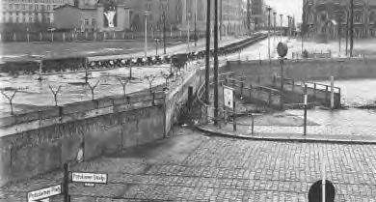 |  | Did you know?  When Khrushchev visited America in 1959, he was taken round an Ideal Home exhibition. At the kitchen display, he had a very public row with American Vice-President Nixon about which was better: Communism or capitalism.  Tasks  1. Discuss with a friend why the U2 incident came at a very bad time for the Americans.  2. Make notes on: ‘The story of the U2 crisis’.  New Words  psychological: in the mind.  Nuclear weapons: atomic and hydrogen bombs and ICBMs – inter-continental ballistic missiles.  Sabotage: causing damage  Source B  The Americans use West Berlin as a base for recruiting spies, sabotage and starting riots. The wall will keep East Germany safe.  The Russian explanation of the Wall, 1961  Source C  There were FOUR results of the Berlin Wall:  - Berlin was split in two. Hundreds of East Berliners died trying to cross it.  - America complained, but did not try to take it down – it was not worth a war.  - Tension grew: both sides started nuclear testing.  - The West became more anti-communist (Source D)  Source D  Some people say we can work with the Communists. Let them come to Berlin.  President Kennedy, 1961.  ⬅ The Berlin Wall, 1961  Tasks  1. Prepare a 15-minute essay: ‘Describe the events 1958–1961 which led to the Berlin Wall’.  2. Copy Source C.
The Cuban Missiles Crisis – Causes  1. Superpower Tension  All the tensions that had grown up between Russia’s assertive ‘peaceful competition’ and Kennedy’s promise to be tough on Russia – including the space race, the arms race and nuclear testing, American funding of anti-Communists in Vietnam and Laos, the failed Vienna summit (1961) and the Berlin Wall.  2. Fidel Castro’s Cuba  In 1959, the Communist Fidel Castro took power in Cuba. This was very threatening to the USA because it was right next to America. In 1960, Castro made a trade agreement with Russia, whereby Cuba sent sugar to Russia, in return for oil, machines and money. This frightened the Americans more, and in 1960 they stopped trading with Cuba. In retaliation, Cuba nationalised all American-owned companies  3. The Bay of Pigs.  In April 1961 the CIA encouraged, funded and transported an attempt by anti-Castro Cuban exiles to invade Cuba. It failed miserably, greatly embarrassing Kennedy. In September 1961, therefore, Castro asked for – and Russia publicly promised – weapons to defend Cuba against America.  On 14 October an American U2 spy-plane took pictures of a nuclear missile base being built on Cuba. Kennedy’s advisers told him he had 10 days before Cuba could fire the missiles at targets in America.  Kennedy decided he had to act (see Source A).  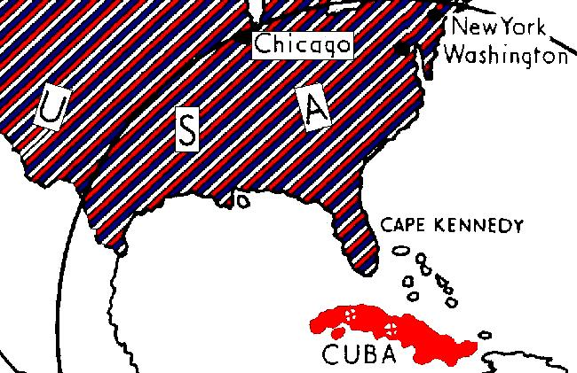  The Cuban Missiles Crisis  16 Oct: Kennedy set up a Committee of the National Security Council to advise him.  22 Oct: Kennedy announced that he was mounting a naval blockade of Cuba.  23 Oct: Khrushchev accused America of piracy. He warned that Russia would get ready ‘a fitting reply to the aggressor’. 20 Russian ships were heading for Cuba.  24 Oct: The first Russian ship reached the naval blockade. It was an oil ship and was allowed through. The other Russian ships (carrying missiles) turned back. However, Russia was still building the missile bases.  26 Oct: Khrushchev sent a letter to Kennedy, offering to dismantle the sites if Kennedy would lift the blockade and agree not to invade Cuba.  27 Oct: Before Kennedy could reply, Khrushchev sent another letter, demanding that Kennedy also dismantle American missile bases in Turkey. On the same day, a U2 plane was shot down over Cuba.  It looked as if war was about to happen.  Kennedy ignored the plane incident. He also ignored Khrushchev’s second letter – he wrote simply that would lift the blockade and agree not to invade Cuba if Khrushchev would dismantle the missile bases.  28 Oct: Khrushchev agreed. The crisis finished.  20 Nov: Russian bombers left Cuba, and Kennedy lifted the naval blockade.  The results were:  1. Khrushchev lost prestige – he had failed. Particularly, China broke from Russia.  2. Kennedy gained prestige. He was seen as the men who faced down the Russians.  3. Both sides had had a fright. They were more careful in future. The two leaders set up a telephone ‘hotline’ to talk directly in a crisis.  In 1963, they agreed a Nuclear Test Ban Treaty. Cuba was the start of the end of the Cold War.  4. Cuba remained a Communist dictatorship, but America left it alone. |  | New Words  nationalise: where the government takes over a business/ industry.  naval blockade: to not allow ships to come or go from Cuba.  Source A  We will not needlessly risk world-wide nuclear war in which even victory would be ashes in our mouths – but neither will we shrink from that risk when it must be faced . . . I call upon Chairman Khrushchev to stop and dismantle this secret, reckless and provocative threat to world peace.  Speech by President Kennedy on American TV, 1962.  ⬅ The danger of the missile bases.  Task  Prepare a 15-minute essay: ‘Why was there a crisis about Cuba in 1962?  Source B  Kennedy’s Options:  - Nuclear Strike? It would cause a nuclear war.  - Conventional attack? There were Russian troops in Cuba, and it would probably lead to a war with Russia.  - Use the UN? Too slow.  - Do nothing? The missile bases were too dangerous.  - Blockade? This would stop the missiles getting to the missile bases, but it was not a direct act of war.  Did you know?  Kennedy did not publicly agree to dismantle missile bases in Turkey. But in a secret telephone call, he told Khrushchev that – while he couldn’t agree to dismantle Turkish bases in a ‘tit-for-tat’ agreement – the USA did not see any need for them and that they would be dismantled soon.  Tasks  1. Prepare a 15-minute essay: ‘Describe the events of the Cuba Crisis of 1962.  2. Copy ‘The Results of the Cuba Crisis’.

Revision Questions

- When did Stalin die? Who became the new leader of Russia
- What were the meetings between the superpower leaders called?
- What did Khrushchev tell Tito in 1955?
- What did Khrushchev say about Stalin in 1956?
- What was Khrushchev’s policy called? What did he really mean by it?
- What was de-stalinisation? Why was it dangerous for world peace?
- How did Khrushchev build up support in countries like Afghanistan and Burma?
- What was the first satellite and when was it launched?
- Who was the first astronaut to orbit the earth, and when did he do it?
- When did Russia get the hydrogen bomb?
- What was the military alliance set up by Khrushchev, and what countries were in it?
- Which American senator led a ‘witch-hunt’ for communists in America?
- What did NATO agree to in 1955 in West Germany?
- How did America spy on Russia?
- Name the FIVE crises after 1955.
- Who led the Polish riots of 1956?
- Which Polish Communist kept control of Poland?
- List the FIVE reasons for the Hungarian uprising.
- Who rioted in Hungary on 23 October 1956, and what did they do?
- Who became the Prime Minister of Hungary?
- What FOUR reforms did the rebels order?
- What FIVE reasons led Russia to send in the tanks? Of these, which was most important?
- How many tanks invaded Budapest.
- Why did Britain and France not help Hungary?
- Who was the President of America in 1956? Why did he not help Hungary?
- Why did the UN not help Hungary?
- Who did Khrushchev put in charge of Hungary?
- How many Hungarians fled to Austria?
- What did Khrushchev demand from America in 1959?
- With whom did Khrushchev argue about kitchens in 1959?
- What crisis began on 5 May 1960.
- Which summit meeting was ruined because of the crisis?
- Who did the Americans elect as their President in 1961?
- Which two places in the Far East did Kennedy finance anti-communist fighters?
- How many refugees had fled to West Berlin by 1961? Why was this bad for Russia?
- What did Khrushchev demand at the Vienna summit of June 1961?
- What date did Khrushchev begin to build the Berlin Wall?
- Why did Khrushchev say he built the wall?
- When did Fidel Castro come to power in Cuba?
- What did his 1960 trade agreement with Russia say?
- What did Castro do to America companies in 1961 which angered America?
- What was the name for the failed invasion of Cuba in 1961. Why was it an embarrassment for Kennedy?
- What did a U2 spy-plane discover on Cuba in October 1962?
- What were Kennedy’s FIVE options, and which did he choose?
- What did Khrushchev accuse America of?
- What deal was done between Kennedy and Khrushchev?
- What event during the crisis (27 Oct) almost caused a nuclear war?
- What did the two leaders set up after the Missiles Crisis to prevent another such crisis?
- What agreement began the thaw in 1963?

