The Peace Treaties, 1919–1920

In this module you will learn:

- THIRTY new words
- The names of the ‘Big Three’ leaders at the Versailles Conference.
- The aims of Clemenceau (4), Wilson (7) and Lloyd George (5) at the Conference.
- The FOUR main terms of the Treaty of Versailles [BRAT].
- Five reasons the Germans were angry about the Treaty of Versailles.
- What Clemenceau, Wilson and Lloyd George felt about the Treaty of Versailles.
- The FOUR other treaties of 1919–1920.
- FOUR reasons the Treaty of Versailles was more important than them.
- FIVE new nation-states created in 1919–1920.
- Four problems with self-determination.

You must do the following written work:

❒ A spidergram of how people felt after the First World War.
❒ A wordsearch on the Aims of the Big Three.
❒ A video sheet ‘Make Germany Pay’.
❒ An essay: ‘How did the victorious countries intend to treat Germany in 1919?’
❒ A cloze exercise: The Terms of the Treaty of Versailles [BRAT].
❒ An essay: ‘Why were the Germans so angry about the Treaty of Versailles’.
❒ Sentences on what the British people
Woodrow Wilson thought about the Treaty.
❒ Questions on the Other Treaties of 1919–1920.

Have you read:
❒ Peter Moss, History Alive 4, chapter 4.
❒ LE Snellgrove, The Modern World since 1870, chapter 11.
❒ Christopher Culpin, Making History, chapter 3.
❒ N deMarco and R Radway, The Twentieth Century, pages 144–8.
❒ J Traynor and I Dawson, The Struggle for Peace, chapter 4.
❒ Tony McAleavy, Modern World History, pages 12–29.

Q  Share what you remember about the First World War.  The Versailles Conference  The First World War (1914–1918) had been bad.  10 million people died. The part of France where there had been fighting – the ‘Western Front’ – was totally destroyed.  In November 1918, Germany had signed a cease-fire. It was called ‘the Armistice’. The Germans could not fight any longer. But they did not think they had surrendered!  In January 1919, delegates from 32 countries met at Versailles, near Paris, to make treaties to end the war. The meeting was known as the Versailles Conference.  This module studies what happened at the Conference, the treaties that the leaders made, and what the world thought about them  Source A  A picture of Soissons in 1918, showing the damage done during the war. |  | New Words  Versailles: a famous palace near Paris.  Conference: a meeting.  Armistice: a cease-fire.  Treaty: an agreement between nations.  Delegate: a person representing a country at a conference.
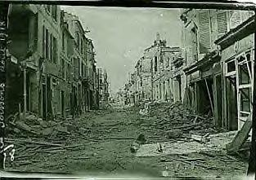
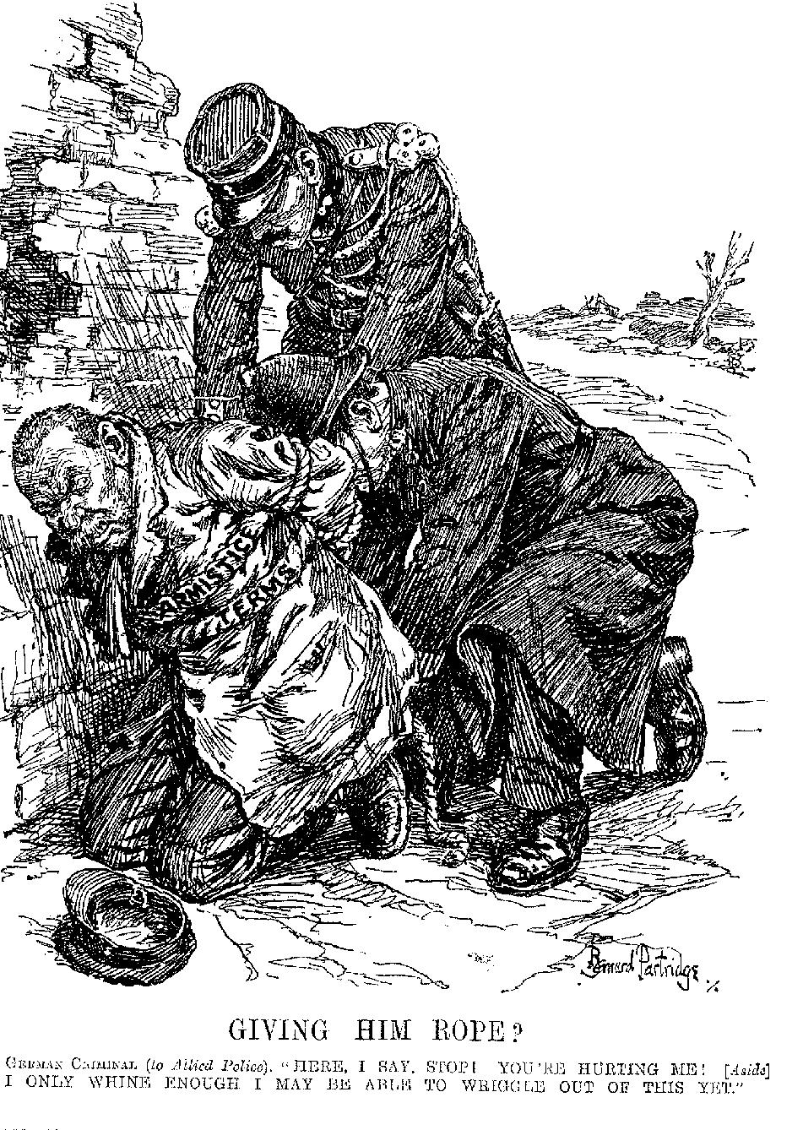  Tasks  - Look at Sources A and B. Make a spidergram to show what would you have been thinking and feeling if you had been going as a delegate to the Versailles Conference?  - Read Source C. Imagine you are Mr Geddes’s speech-writer. Write the next paragraph, in which he explains WHY he wants to do this. |  | ⬅ Source B  What is this cartoon of 1919 saying about the Germans?  Did you know?  When the Russians had wanted to stop fighting in 1917, the Germans had made them sign the Treaty of Brest-Litovsk. It took lots of land from Russia.  When they heard about this, many politicians decided that they would be just as tough on Germany.  Source C  Germany is going to pay. We will get everything you can squeeze out of a lemon, and a bit more. The Germans should hand over everything they own.  From a speech in 1918 by Sir Eric Geddes, a British politician standing for election as an MP.

The Aims of ‘the Big Three’

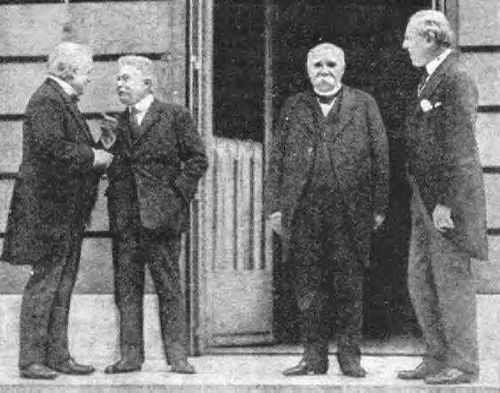  The three most important men at the Versailles Conference – ‘the Big Three’ – were:  - Georges Clemenceau, the Prime Minister of France.  - Woodrow Wilson, the president of America.  - David Lloyd George, the Prime Minister of Britain.  All three men wanted to stop a war ever happening again, but they did not agree about how to do this. They wanted different things from the peace, and they did not get on well.  New Words  Georges Clemenceau.  Woodrow Wilson.  David Lloyd George.  Colonies: overseas countries ruled by a European nation (e.g. India was a colony of the British Empire).  Disarmament: where countries agree to reduce their weapons.  Self-determination: the right of nations to rule themselves.  Compromise: when you ‘meet someone half-way’ in an argument.  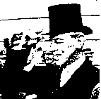  Woodrow Wilson  He was President of America.  He was a History professor. He wanted to make the world safe.  He wanted to end war by making  a fair peace.  In 1918, Wilson published ‘Fourteen Points’ saying what he wanted. He said that he wanted disarmament, and a League of Nations (where countries could talk out their problems, without going to war).  He also promised self-determination for the peoples of Eastern Europe. |  | 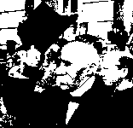  Georges Clemenceau  He was the Prime Minister of France.  He wanted revenge, and to punish the Germans for what they had done.  He wanted to make Germany pay for the damage done during the war.  He also wanted to weaken Germany, so France would never be invaded again.  Task  Divide into groups of three. Each person takes the role of one of the Big Three – Clemenceau, Wilson or Lloyd George.  Study what your character wanted from the peace, then re-enact a meeting between the three leaders. Discuss the following:  - What should happen to the German army, navy and airforce?  - How much should Germany be asked to pay for the damage done during the war – a lot, or a little?  - How much land should Germany lose?  - Should the Treaty blame Germany for the war?  - What is the best way to stop a war ever happening again?  - Remember to explain to the others WHY you want the things you want.  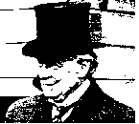  David Lloyd George  He was Prime Minister of England.  He said he would ‘make Germany pay’ – because he knew that was what the British people wanted to hear.  He wanted ‘justice’, but he did not want revenge. He said that the peace must not be harsh – that would just cause another war in a few years time.  He tried to get a ‘halfway point’ – a compromise between Wilson and Clemenceau.
Essay!
[memorise this essay, then try to write it out from memory]
How did the victorious countries intend to treat Germany in 1919?
A million Frenchmen had died in the war; the French wanted revenge, to punish the Germans for what they had done. They wanted to make Germany pay for the damage done during the war. Finally, they wanted to weaken Germany, so France could never be invaded again.
(4 things)
America had not been ruined by the war, so the American president, Woodrow Wilson only wanted a ‘fair peace’, which would make the world safe, and end war. Wilson also wanted disarmament, a League of Nations (where countries could talk out their problems), and self-determination for the peoples of Eastern Europe – the ‘Fourteen Points’.
(7 things)
Some British people wanted to make Germany pay – ‘everything you can squeeze out of a lemon’. Many, however, like their Prime Minister, David Lloyd George, realised that the peace must not be harsh, or there would be another war in a few years time. Lloyd George said he wanted ‘justice’ – a halfway point between Clemenceau’s revenge and Wilson’s ideals.
(5 things)

The Terms of the Treaty of Versailles

The main points of the Treaty
After the war, the victors met at the Palace of Versailles, near Paris, to tell Germany the terms of peace.  Defeated Germany was not allowed to send any delegates, and had no choice but to accept whatever was decided.  Most of the delegates wanted revenge.  Only President Woodrow Wilson of the United States wanted a better world. |  | - Germany had to accept the blame for starting the war.  - Germany was forbidden to have submarines or an air force. She could have a navy of only six battleships, and an army of just 100,000 men. In addition, Germany was not allowed to place any troops in the Rhineland, the strip of land, 50 miles wide, next to France.  - Germany had to pay £6,600 million, called reparations, for the damage done during the war.  - Germany lost land in Europe (see map, below). Germany’s colonies were given to Britain and France.  - Germany could not join the League of Nations.  - Germany could never unite with Austria.

Source A
A map showing Germany’s loss of territory by the Versailles Treaty.

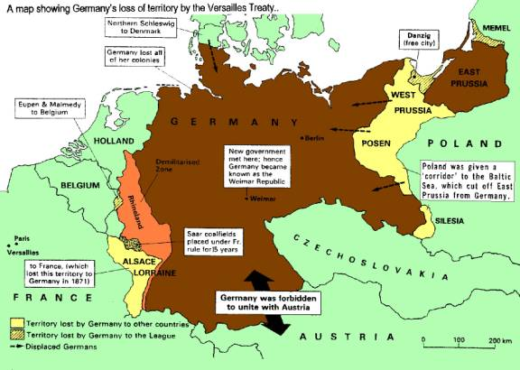
Q  Describe a time when you were unfairly treated.  The Germans and the Treaty  When the Germans heard about the Treaty of Versailles, they felt ‘pain and anger’. They felt it was unfair. They had not been allowed to take part in the talks – they had just been told to sign.  At first they refused to sign the Treaty. Some Germans wanted to start the war again.  The Germans were angry at Clause 231; they said they were not to blame for the war. The soldier sent to sign the Treaty refused to sign it – ‘To say such a thing would be a lie,’ he said.  The Germans were angry about reparations; they said France and Britain were trying to starve their children to death. At first they refused to pay, and only started paying after France and Britain invaded Germany (January 1921).  The Germans were angry about their tiny army. They said they were helpless against other countries. At first they refused to reduce the army, and the sailors sank the fleet, rather than hand it over.  The Germans also thought the loss of territory was unfair. Germany lost a tenth of its land. Other nations were given self-determination – but the Treaty forced Germans to live in other countries. Germans were also angry that they could not unite with the Austrian Germans.  Tasks  1 List the key words and phrases in Source A which show us how the Germans felt about the treaty.  2 Divide into groups of about 5–6.  Devise a role play in which you are a group of Germans talking about the Treaty of Versailles in June 1920.  You have just found out what the Treaty says.  Talk about:  what the Treaty says,  what you feel about the terms of the Treaty,  how much you hate the Treaty, and why,  what you are going to do about it. |  | New Words  Clause 231: the paragraph blaming Germany for the war.  reparations: the money Germany had to pay for damage done during the war.  terms of the Treaty: the different things the Treaty said.  Did you know?  The Treaty of Versailles helped Adolf Hitler’s rise to power.  A lot of Germans supported him because he promised to destroy the Treaty.  Source A  The disgraceful Treaty is being signed today.  Don’t forget it!  We will never stop until we win back what we deserve.  From a German newspaper of 28 June 1920.

New Words  Demilitarised zone: an area where the army is not allowed to go.  Senate: the ‘parliament’ of the United States.  Source A  We shall have to fight another war again in 25 years time.  Lloyd George, talking about the Treaty of Versailles.  Tasks  Study Source B. Why is the child weeping? What is the cartoon saying about the Treaty of Versailles?  Read Source A. Does it contradict Source B, or agree with it?  Why did many British people hate the Treaty?  Source B ➔  A British cartoon of 1920.  How old will the weeping child be in 1940? |  | Verdicts on the Treaty  Clemenceau:  liked the harsh things that were in the Treaty:  - Reparations (would repair the damage to France),  - The tiny German army, and the demilitarised zone in the Rhineland (would protect France),  - France got Alsace-Lorraine, and German colonies.  But he wanted the Treaty to be harsher.  Wilson:  Wilson got self-determination for the peoples of Eastern Europe, and a League of Nations, but he hated the Treaty:  - few of his ‘Fourteen Points’ got into the Treaty,  - when Wilson went back to America, the Senate refused to join the League of Nations, and even refused to sign the Treaty of Versailles!  Lloyd George:  Many British people wanted to ‘make Germany pay’, but Lloyd George hated the Treaty. He liked:  - the fact that Britain got some German colonies,  - the small German navy (helped British sea-power).  But he thought that the Treaty was far too harsh.  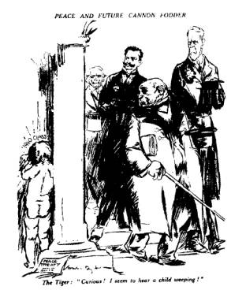

After 1919: Dates List

18 Jan 1919 Paris Peace Conference begins.
14 Apr 1919 Reparations provisionally set at £5.4 billion
21 Jun 1919 Germans scuttle their fleet, at Scapa Flow, rather than hand it over to the Allies.
28 Jun 1919 Treaty of Versailles signed (reparations set at £1 billion).
12 Sep 1919 Gabriele d’Annunzio and an Italian army seize Fiume, against the Treaty,
19 Nov 1919 US Senate refuses to join the League of Nations.

16 Jan 1920 First meeting of the League of Nations.
5 Feb 1920 The German government refuses to hand over 890 alleged ‘war criminals’.
19 Feb 1920 US Senate refuses to sign the Treaty of Versailles.
17 Mar 1920 Kapp Putsch (rebellion) in Germany, against the peace treaty, fails.
6 Apr 1920 French troops invade Ruhr in Germany (until 17 May 1920) after the German government had sent troops into the Rhineland to stop rioting.
25 April 1920 Poland invades Russia and Lithuania and takes land east of the ‘Curzon line’ agreed in the Treaty of Versailles.
25 April 1920 The League of Nations suggests reparations of £4.5 billion.
22 Jun 1920 The League of Nations suggests reparations of £12.5 billion.
28 Jul 1920 The Allies bully Poland into accepting Czech occupation of Teschen.

28 Jan 1921 The League of Nations suggests reparations of £10 billion.
8 Mar 1921 French, British and Belgian troops invade the Ruhr in Germany (until 30 Sep 1921) to force Germany to pay reparations.
27 April 1921 Reparations finally fixed at £6.6 billion, to be paid in instalments until 1984.
11 May 1921 Germany agrees to pay reparations.
11 Jul 1921 The ‘Big Three’ agree to hold a disarmament conference.

15 May 1922 Upper Silesia, which had voted in a plebiscite to be German, is partitioned and given to Poland after an investigation by the League of Nations.
26 Jul 1922 An economic crisis in Germany (until 1924). Britain and France agree to a 6 months delay in reparations payments.

11 Jan 1923 French and Belgian troops, against US and Britain’s advice, invade the Ruhr in Germany (until Nov 1924) to force Germany to pay reparations.
21 Jan 1923 The German miners go on strike against the French invasion, which deepens the economic crisis in Germany.
21 Oct 1923 Bavaria and Rhineland declare independence from Germany (Germany is falling apart).
8–9 Nov 1923 Hitler’s Munich Putsch fails.

9 Apr 1924 The Dawes Plan gives Germany longer to pay reparations, and grants huge loans to get the German economy going.
2 Dec 1924 Trade Treaty between Britain and Germany.
16 Oct 1925 Locarno Pact: peace agreement between Fr., Br., Belgium, Italy & Germany.

30 Jan 1926 British troops leave the Rhineland.
5 Aug 1926 France and Germany sign a trade agreement.
8 Sep 1926 Germany admitted to the League of Nations.

16 Sep 1927 German President Hindenburg denies German War Guilt; nothing is done.

27 Aug 1928 Kellogg-Briand Pact: 65 nations (inc. Fr/Br/USA/Ger) promise to abolish war.

7 Jun 1929 The Young Plan reduces reparations.
24 Oct 1929 Wall Street Crash; USA recalls all loans, causing an economic crisis in Europe.
30 Jun 1930 Last Allied troops leave the Rhineland.
13 Jul 1931 German economic crisis – all banks have to close (until 5 Aug 1931). USA, France and Britain give Germany a huge loan.
9 Jul 1932 Lausanne Agreement: USA, France and Britain suspend all reparations payments indefinitely.

New Words  principles: ideas which say how things should happen.  disarm: give up your armies and navies.  self-determination: the right of peoples to rule themselves.  nation-state: a country where the people of a certain race rule over themselves.  Racial minority: where a few people of one race live in a country where most people are of a different race  Tasks  Find four reasons the Treaty of Versailles was more important than the other treaties of 1919–20.  Write down the names of the four other treaties of 1919–20.  Copy what the four other treaties said.  Write down the names of five new nation-states created by the treaties of 1919–20.  Write down four problems facing the new nation states. |  | The Other Treaties of 1919–1920  The Treaty of Versailles was not the only treaty of 1919–20. But it was the most important.  It was the treaty with Germany, and was decided by the Big Three. It was the Treaty which set up the League of Nations. Also, the Treaty of Versailles set down the principles of how the defeated countries would be dealt with:  - the defeated countries had to pay reparations,  - they had to disarm,  - they lost land,  - self-determination.  The Treaties [SaiNTS]  Four other treaties were made with the four countries who had helped Germany in the war. They were written by officials. They just followed the principles of the Treaty of Versailles.  The Treaties were all named after parts of Paris:  - Saint Germain (with Austria),  - Neuilly (with Bulgaria),  - Trianon (with Hungary) and  - Sèvres (with Turkey).  What the Treaties said  All four countries had to pay reparations, they all had to disarm, and they all lost land.  The treaties also created new nation-states in Eastern Europe out of the old Austro-Hungarian Empire.
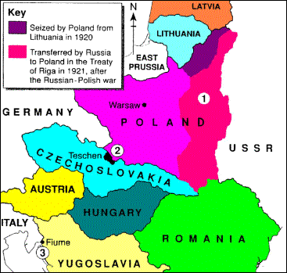

⬆ Source A  A map of Eastern Europe in 1920.  Self-determination caused three small wars:  - Poland went to war with Russia and took more land.  - Czechs and Poles fought over the town of Teschen.  - An army of Italians marched into the Yugoslavian town of Fiume. |  | Self-determination [CHAPS]  The treaties created new nation-states (see map above):  - Czechs and Slovaks in Czechoslovakia  - Hungarians in Hungary  - Austrians in Austria.  - Poles in Poland,  - Slavs in Yugoslavia,  so it seems that self-determination was a success!  Problems with self-determination [WiGWaM]  - Self-determination caused small Wars (see map).  - Self-determination was not allowed for Germany.  - A large number of small, Weak countries were created, which Hitler easily conquered later.  - All the new nation-states had racial Minorities living in them.

Revision Questions

- What was the ceasefire of November 1918 called?
- When did the Versailles Conference begin?
- How many countries attended the Conference?
- What did Sir Eric Geddes want?
- Who were the three most important men at the Conference?
- What was their nickname?
- Who was the prime minister of France?
- List 4 things Clemenceau wanted from the peace.
- Who was the President of America?
- Give 7 things Wilson wanted from the peace.
- What were his ideas for a better world called?
- What were the 3 main ideas of the Fourteen Points?
- What was the name for the assembly, where Wilson wanted countries to talk about their problems, instead of going to war?
- Who was the Prime Minister of Britain?
- Give 5 things Lloyd George wanted from the peace.
- What were the FOUR terms of the Treaty of Versailles?
- Which Clause blamed Germany for the war?
- What were ‘reparations’?
- How much were reparations eventually set at?
- Explain the 5 things the Treaty said about Germany’s armed forces.
- List four areas of land in Europe that Germany lost.
- What is the word which means that troops were not allowed in the Rhineland?
- What happened to Germany’s colonies?
- What did the Treaty say about Austria?
- Why did the Germans refuse to agree to Clause 231?
- What made the Germans pay reparations in January 1921?
- Why were the Germans angry about their tiny army?
- What did the German sailors do to the fleet?
- How much of its land did Germany lose?
- Explain why the Germans thought the Treaty was unfair.
- What did the Germans feel when they heard about the Treaty?
- Who did the Treaty helped to rise to power.
- What did a German newspaper promise?
- List 5 things Clemenceau liked about the peace.
- Why did he dislike it?
- What two things did Wilson get that he wanted?
- Why did he hate the Treaty?
- Two things happened when Wilson went home. What?
- Lloyd George liked two things about the Treaty. What?
- What did Lloyd George hate about the Treaty?
- What did Lloyd George say about the Treaty?
- List the four other treaties of 1919–20.
- List four reasons the Treaty of Versailles was more important than these treaties.
- What were the four main principles of the Treaty of Versailles?
- What does ‘self-determination’ mean.
- List 5 new nation-states created by the treaties of 1919–20.
- Which empire did it split up to make these new nation-states?
- Which races ruled in Czechoslovakia?
- Which people ruled in Yugoslavia?
- List four problems with self-determination.

