Votes for Women

1. How useful is Source 1 for an historian who wants to know about public attitudes to the Suffragettes’ campaign?

Target : Use of historical sources critically in context (AO6.2) 10

Source 1
A poster (1912) by John Hassall for the National League for Opposing Woman Suffrage:

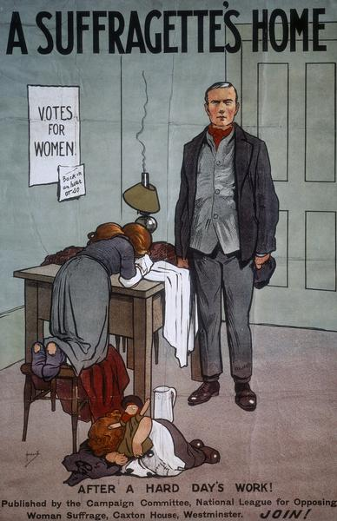
John Hassall was a well-known artist of the time – perhaps his most famous picture being the amusing advertisement ‘Skegness is so bracing’. He was commissioned to produce this poster by the National League for Opposing Woman Suffrage.

2. Using Sources 2–6 and your own knowledge, which would you say was the more important factor in why women in won the vote:
• The actions of the Suffragettes
• The part played by women during the First World War?
You MUST refer to both opinions when explaining your answer.
You MUST refer to all the sources 2–6 in your answer. (15)

Target: The deployment of knowledge to describe, analyse and explain (AO6.1).

Source 2

A Suffragette on the Suffragettes
The argument of the broken pane of glass is the most valuable argument in modern politics.
Mrs Emmeline Pankhurst, speaking on 16 February 1911.
Emmeline Pankhurst was the leader of the WSPU.

Source 3

A Government Minister on the Suffragettes
Haven’t the Suffragettes the sense to see that the very worst way of campaigning for the vote is to try and intimidate a man into giving them what he would gladly give otherwise?
Lloyd George, speaking in 1913.

Lloyd George was the Chancellor of the Exchequer. Although he was not opposed to votes for women, he believed that the government could not be seen to give way to force.

Source 4
The Effects of the War according to Constance Rover
It is frequently said that women were given the vote ‘because of the war’… The war changed the situation in more ways than are obvious at first sight. The obvious effect was that women’s contribution to the war effort was seen and appreciated and that women, instead of being subjected to frequent criticism in the press and by public figures, were very generally praised. Public opinion became overwhelmingly favourable towards women.
Constance Rover, Women’s Suffrage and Party Politics in Britain 1866–1914 (1967)
Constance Rover was one of the first feminist historians, and is very highly regarded historian.

Source 5
The Effects of the War according to Paula Bartley
It would be naïve to believe that women received the vote solely for services rendered in the First World War. It must be remembered that only women over 30 were given the vote and the very women who had helped in the war effort – the young women of the munitions factories – were actually denied the vote. The significance of women’s war work in the achievement of the vote is therefore perhaps not as great as first assumed. In reality, women were greatly resented in both agriculture and industry… Men ‘froze out’ women workers, gave them no help and even sabotaged their work… The reasons for the shift which took place in Government thinking therefore need consideration.
Paula Bartley, Votes for Women 1860–1928 (1998)
Paul Bartley is Senior Lecturer in History at the University of Wolverhampton and an acknowledged expert on women’s history.

Source 6
Different Claims
To this day, many people equate the British women’s suffrage struggle and the final victory with the famous Pankhurst family and their militant supporters in the WSPU. In its early years the WSPU was a bold, innovative, imaginative organisation, among the first to appreciate the value of publicity. Not without justification, its members regarded themselves as the elite soldiers of the ‘Votes for Women’ campaign. But for every suffragette there were always dozens of non-militant suffragists. Some would argue – including me – that it was the moderates of the NUWSS, led by Millicent Fawcett, who actually won the vote. In 1912, while the militants embarked on arson and bombing, the NUWSS made a successful working alliance with the growing Labour Party. It was this group which successfully lobbied for the 1918 Franchise Act.
Joyce Marlow, Votes for Women (2000)
Joyce Marlow was an actress before she became a full-time writer. She writes novels and books about women’s history

