1.4 Importance of Spain to Carthage
With the loss of Sicily and Sardinia, Carthage needed to recover some income and revenues. It affected the wealth of the traders and also the opportunities of the craftsmen and seamen. In addition there was a war indemnity to pay to the Romans. The Carthaginians and Hamilcar Barca in particular therefore looked to Spain as an alternative source of manpower and money. Spain had supplies of timber, minerals and soldiers. Hamilcar was sent there in 237 BC, perhaps also because the ruling families of Carthage were becoming worried at his growing popularity and power.
It is questionable whether Hamilcar, and afterwards Hannibal, had really been planning to renew the war with Rome and take revenge for the defeat from the start of the campaign in Spain. In Spain Hamilcar could train and develop support for an army without intervention from the Romans. He could not have acted without the support of the government in Carthage and the supply of money and goods ensured support. In 231 BC a Roman embassy came to check on what he was doing and he replied that he was simply getting money to pay of the war indemnity to the Romans. In 226 BC Hasdrubal agreed a treaty with the Romans that he would not cross north of the River Ebro with an armed force.

1.5 Saguntum
Saguntum was south of the Ebro, but also an ally of Rome. When Hannibal demanded its surrender, Rome ordered him to respect their ally. The Romans went onto Carthage itself but did not get an agreement there either. One group in Saguntum had appealed to Rome to help over a dispute with a local tribe (the Torboletae) who were allies of Carthage. Rome had therefore interfered with a Carthaginian ally and Hannibal came to help them in the spring of 219 BC. After an 8 month siege, the city was captured by Hannibal. At this time Rome was occupied with a threat from the Illyrians. The Romans waited until March 218 BC before sending an ultimatum to Carthage demanding the surrender of Hannibal and his staff – this was rejected and war declared.
Hannibal’s attack on Saguntum was not justified for military reasons; while Saguntum was a Roman ally south of the Ebro, it was not a military threat. Hannibal used Saguntum to push Rome into making the declaration of war, so that the government of Carthage would see Rome as the aggressors and so support him. Both Hannibal and his father, Hamilcar, probably saw that Carthage’s extension of power in Spain might renew the rivalry with Rome. They wanted to be prepared for such a war and to fight the war on land. Hasdrubal had maintained good relations with Rome through his treaty. However, they had seen Rome take Sardinia when Carthage was in no position to defend her rights to it. Over Saguntum, Hannibal was not willing to give in again.
However, Livy (21.5) and Polybius (2.36) have no doubt that from the moment Hannibal took command he intended to make war on Rome.

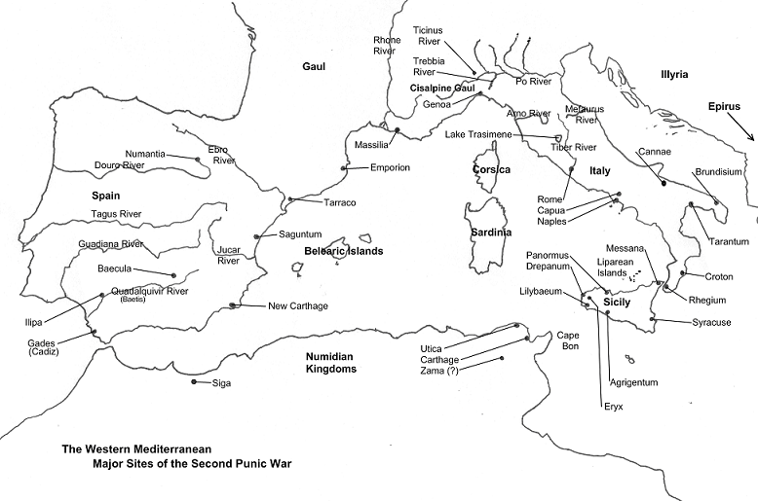
1.6 The Barcids in Carthage
The Barcids were one of the leading noble families in Carthage. They opposed the expansion of Rome as a threat to Carthage. The following were members of this family:
Hamilcar Barca (275-228 BC): the most successful of the Carthaginian generals in Sicily where he led a guerilla war against the Romans in the latter part of the war and negotiated the peace with the Romans; Livy tells us that the loss of Sicily and Sardinia angered him greatly (Book 21.1). He felt Rome had deceived Carthage. He had been successful also in defeating the mercenaries in Africa who had threatened Carthage. Livy is certain that his nine years in Spain building Carthage’s resources were just a preparation for the invasion of Italy. Polybius (3.10) describes his anger at the peace and his preparation for war in Spain. Both tell the story of how Hamilcar got his 9 year old son, Hannibal, to swear always to be an enemy of the Romans (Livy 21.1, Polybius 3.11).
Hasdrubal the Fair (?-221 BC), Hamilcar's son-in-law, after Hamilcar's death (228 BC), took over command of the forces in Spain; he continued to expand Carthage’s control, and founded Carthago Nova as the capital of the new province.
Hamilacar’s three sons were: Hannibal (247-182 BC); Hasdrubal, (245-207 BC) and Mago.
Hasdrubal defended the Carthaginian cities in Spain while Hannibal fought in Italy. He took reinforcements to Hannibal in 207 BC, and was killed in the Battle of the Metaurus.
Mago (243 - 203 BC) was involved in most of the battles with Hannibal, and was often a very important factor in the victories.

Task 1E
Draw a family tree of the Barcids; include information about the career of Hamilcar and Hasdrubal the Fair in Spain.

